IBM Modernized Runtime Extension for Java (MoRE) Lab

Lab guide

<Level 3 client-facing course codes>



**Document edition: June 2025**

**LEGAL NOTICES**

This information was developed for products and services offered in the USA. IBM may not offer the products, services, or features discussed in this document in other countries. Consult your local IBM representative for information on the products and services currently available in your area. Any reference to an IBM product, program, or service is not intended to state or imply that only that IBM product, program, or service may be used. Any functionally equivalent product, program, or service that does not infringe any IBM intellectual property right may be used instead. However, it is the user's responsibility to evaluate and verify the operation of any non-IBM product, program, or service. IBM may have patents or pending patent applications covering subject matter described in this document. The furnishing of this document does not grant you any license to these patents. You can send license inquiries, in writing, to:

IBM Director of Licensing IBM Corporation  
North Castle Drive, MD-NC119 Armonk, NY 10504-1785  
United States of America

The following paragraph does not apply to the United Kingdom or any other country where such provisions are inconsistent with local law: INTERNATIONAL BUSINESS MACHINES CORPORATION PROVIDES THIS PUBLICATION “AS IS” WITHOUT WARRANTY OF ANY KIND, EITHER EXPRESS OR IMPLIED, INCLUDING, BUT NOT LIMITED TO, THE IMPLIED WARRANTIES OF NON-INFRINGEMENT, MERCHANTABILITY OR FITNESS FOR A PARTICULAR PURPOSE. Some states do not allow disclaimer of express or implied warranties in certain transactions; therefore, this statement may not apply to you. This information could include technical inaccuracies or typographical errors. Changes are periodically made to the information herein; these changes will be incorporated in new editions of the publication. IBM may make improvements and/or changes in the product(s) and/or the program(s) described in this publication at any time without notice. Any references in this information to non-IBM websites are provided for convenience only and do not in any manner serve as an endorsement of those websites. The materials at those websites are not part of the materials for this IBM product and use of those websites is at your own risk. IBM may use or distribute any of the information you supply in any way it believes appropriate without incurring any obligation to you. Information concerning non-IBM products was obtained from the suppliers of those products, their published announcements or other publicly available sources. IBM has not tested those products and cannot confirm the accuracy of performance, compatibility or any other claims related to non-IBM products. Questions on the capabilities of non-IBM products should be addressed to the suppliers of those products.

This information contains examples of data and reports used in daily business operations. To illustrate them as completely as possible, the examples include the names of individuals, companies, brands, and products. All names and references for organizations and other business institutions used in this deliverable’s scenarios are fictional. Any match with real organizations or institutions is coincidental. All names and associated information for people in this deliverable’s scenarios are fictional. Any match with a real person is coincidental.

TRADEMARKS

IBM, the IBM logo, and [ibm.com](http://ibm.com/) are trademarks or registered trademarks of International Business Machines Corp., registered in many jurisdictions worldwide. Other product and service names might be trademarks of IBM or other companies. A current list of IBM trademarks is available on the web at “Copyright and trademark information” at <https://www.ibm.com/legal/copyright-trademark>.

© Copyright International Business Machines Corporation 2025. This document may not be reproduced in whole or in part without the prior written permission of IBM.

Table of Contents

Introduction 1

About this lab 3

Steps for the lab tasks 4

# Introduction

This lab guide walks through the steps to conduct an IBM Modernized Runtime Extension for Java (MoRE) lab.

MoRE introduces the WebSphere administrative model with operational, monitoring, and configuration capabilities currently used to manage Liberty servers. This allows Liberty servers to be managed in the same way as existing Java 8 applications running in traditional WebSphere environments.

The diagram below illustrates a WebSphere Application Server Network Deployment (WAS ND) cell currently running Java 8 applications. This is a concrete cell with multiple nodes, utilizing WAS administrative scripting and the administrative console. When there is a need to migrate certain applications or develop new ones on Java 17 and Liberty, MoRE enables the integration of a managed Liberty runtime into the same cell, as shown in the two Liberty server boxes on the left.

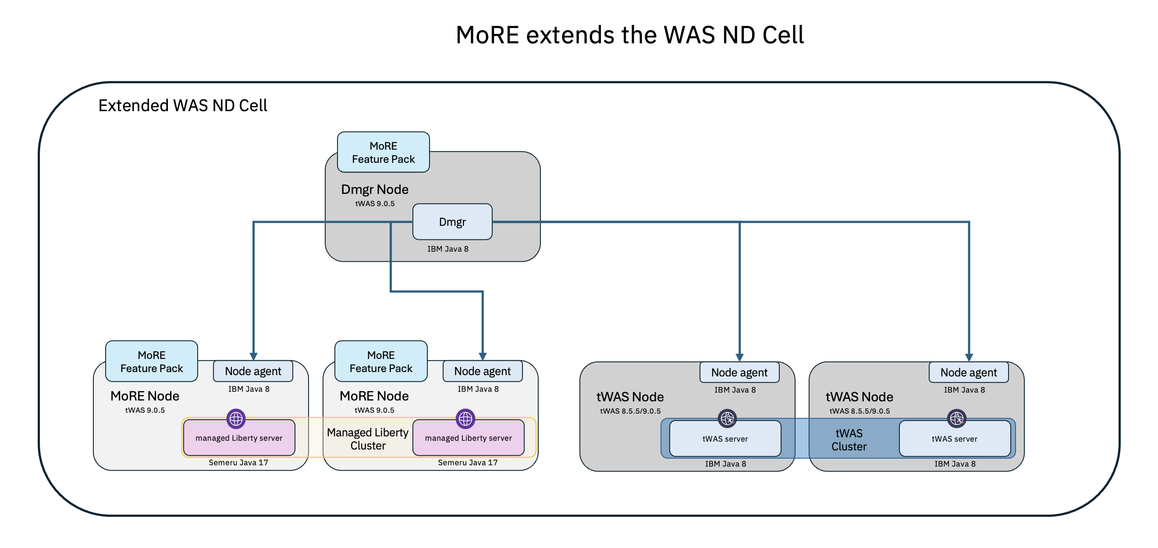

With Liberty running Java 17 and a subset of the Jakarta Enterprise Edition (EE) application programming interface (API), MoRE incorporates managed Liberty servers into the same administrative model used for WebSphere Application Server and other applications. The ability to use the existing administrative model with new applications and Liberty runtimes provides significant value to many current WebSphere clients.

For clients seeking to adopt Java 17 without disrupting current operations, this option offers a practical migration path. It enables Java 17 to run within the existing WAS ND environment without requiring changes to application management or deployment processes. Teams can continue using familiar tools such as the administrative console, Java Management Extensions (JMX), and the deployment manager while transitioning to a modern runtime.

This low-friction approach reduces training requirements, preserves operational stability, and offers flexibility in licensing and deployment. In summary, MoRE enables Java modernization without requiring a complete overhaul of existing systems.

MoRE provides the capability to continue using the traditional WebSphere Application Server (tWAS) Operational Model to manage Java 17 and Java 8 applications within the same traditional WebSphere administrative environment.

The key feature of MoRE 1.0.0.1 is static clusters for running managed Liberty servers in the tWAS cell; support for the Jakarta EE 10 APIs required to run Spring 6 applications is also now available but is not the focus of this demo.

# About this lab

In this lab, you will learn how to extend a WAS ND Cell, using the MoRE feature pak, for managed Liberty servers to manage and run Java 17 / Jakarta EE 10 (subset) applications using the familiar WebSphere administrative mode and admin console.

The lab teaches you how to deploy and run an example application called **Mod Resorts** in a WebSphere cluster, fronted by an IBM HTTP server.

Included with the lab, is a new version of the **Mod Resorts** application that is built using Java 17 and Jakarta 10 EE APIs, which are supported in the managed Liberty Servers (MoRE).

At the end of this lab, you should be able to learn how to:

* Install WebSphere Liberty and MoRE components through IBM Installation Manager
* Create a static cluster with two managed Liberty server (MoRE) cluster members, using the WebSphere Integrated Solutions Console (WAS admin console)
* Install the new Java 17 version of the example application and target the WebSphere cluster, using the WAS admin console
* Start the cluster of managed Liberty servers, using the WAS admin console
* Locate and view the managed Liberty server logs
* View the command assistance for various tasks, showing the wsadmin commands that can be used to perform and automate the tasks.
* Generate and propagate the WebSphere plugin configuration for the IBM HTTP Server
* From the web browser, run the new example application running Java 17 in a WebSphere cluster, through the IBM HTTP Server
* Update the Liberty server HTTP port and test the high availability of the managed Liberty servers cluster.

# Steps for the lab tasks

1. View the installed WebSphere components in IBM Installation Manager.
2. Click the **terminal** icon (A) to open a **terminal** window.

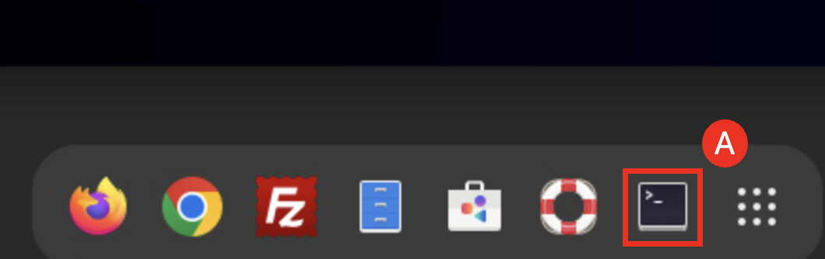

1. In the **terminal** window issue the following command to launch **IBM Installation Manager.**

/home/techzone/IBM/InstallationManager_Group/eclipse/IBMIM

1. In the IBM Installation Manager page, click the **Uninstall** (A). DO NOT UNINSTALL ANY COMPONENTS!

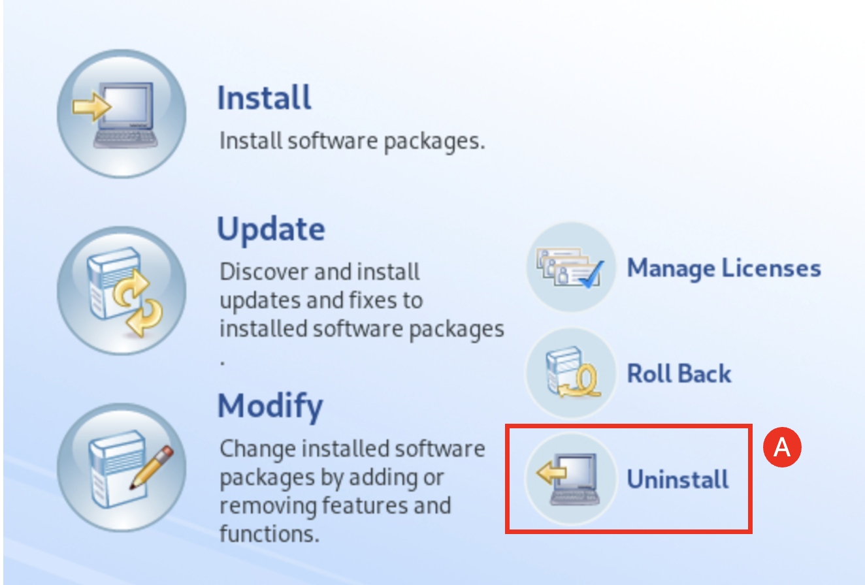

1. Review the installed components, and you can see the WAS ND 9.0.5.24, IHS 9.0.5.24, WebSphere Customization Toolbox 9.0.5.24, and IBM SDK 8.0.8.45 are already installed. This represents a typic traditional WAS ND environment.

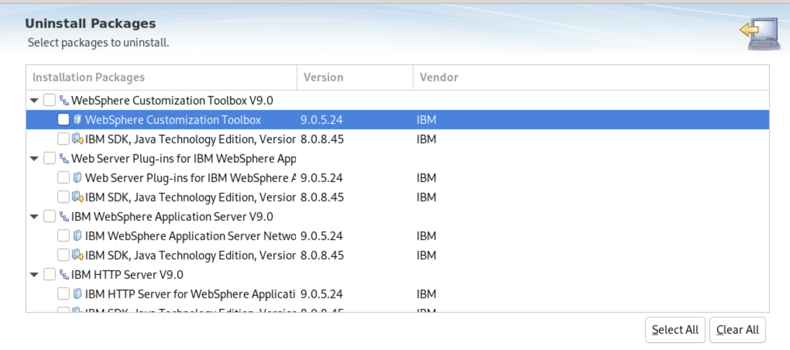

1. **Close** and **Exit** Installation Manager.
2. Start the WebSphere Integrated Solutions Console (WAS Admin Console).
   1. Start the Deployment Manager with commands:

cd /home/techzone/IBM/WebSphere/AppServer/profiles/Dmgr01/bin

./startManager.sh

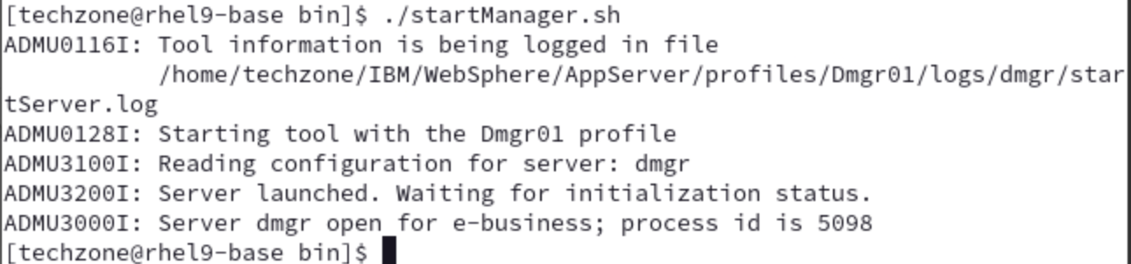

The WAS Deployment Manager is started.

* 1. Open a web browser window by clicking **Activities (A)** and clicking the **Firefox icon (B)**.

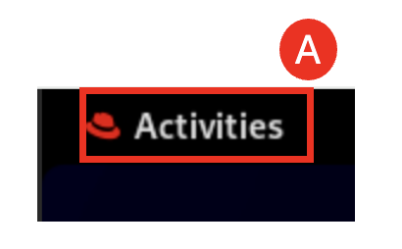

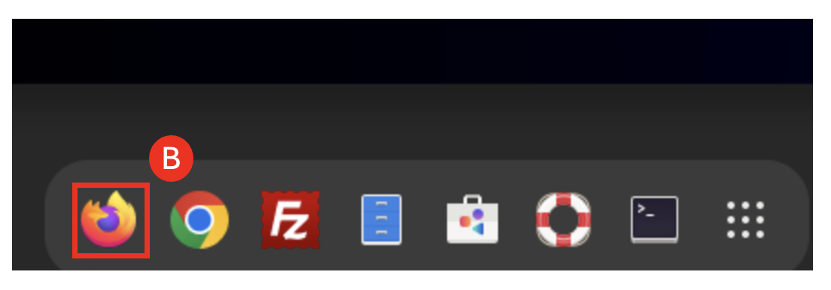

* 1. In the Firefox window, navigate to the WebSphere Integrated Solutions Console (WAS Admin Console) with URL: **https://localhost:9043/ibm/console (A)**

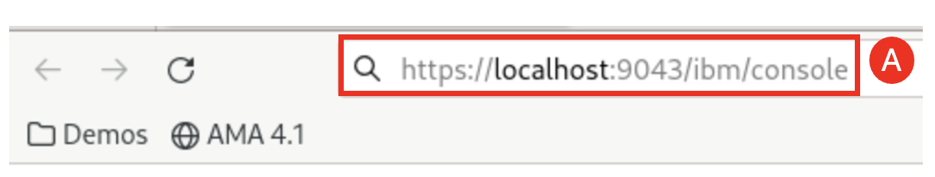

Note: If you see the message “Warning: Potential Security Risk Ahead..”, click **Advanced…** then click **Accept the Risk and Continue**.

* 1. Accept the default user ID and Password and click **Log in (A)**.

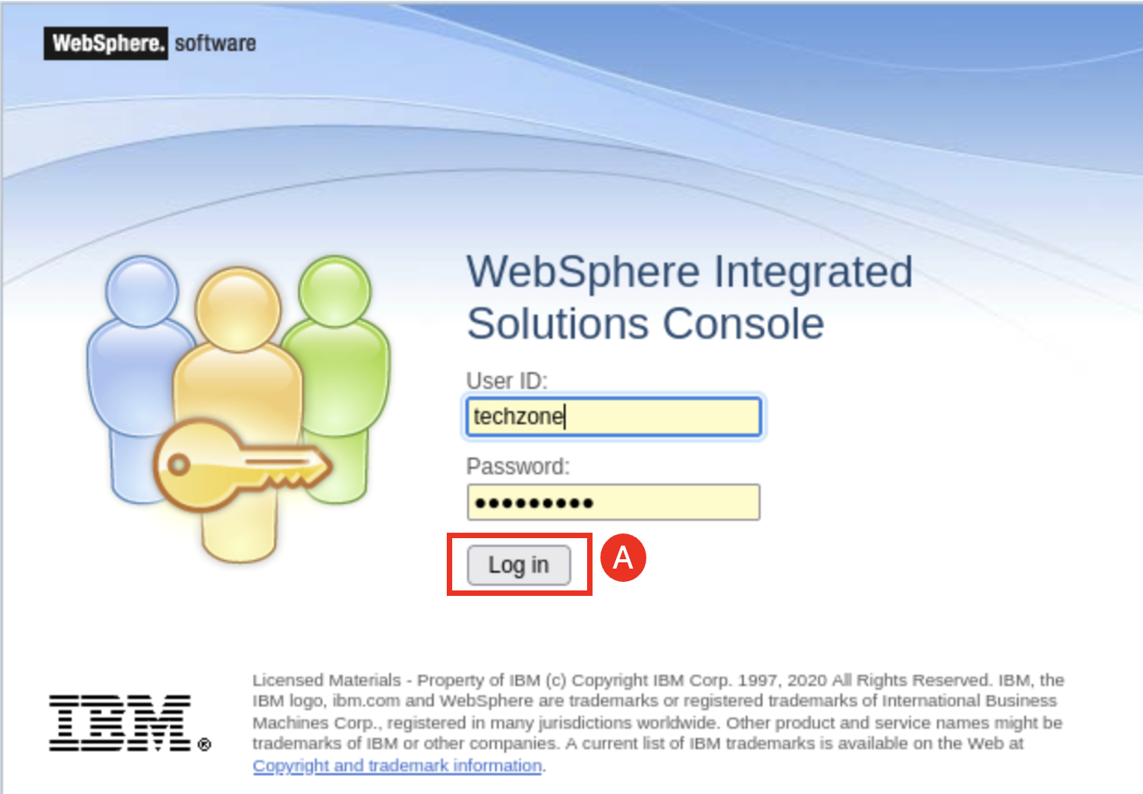

Note: the log in credentials are User ID: techzone Password: IBMDem0s!

* 1. In the WebSphere page click **Servers (A)** and then click **All servers** (B) to view the installed WebSphere servers.

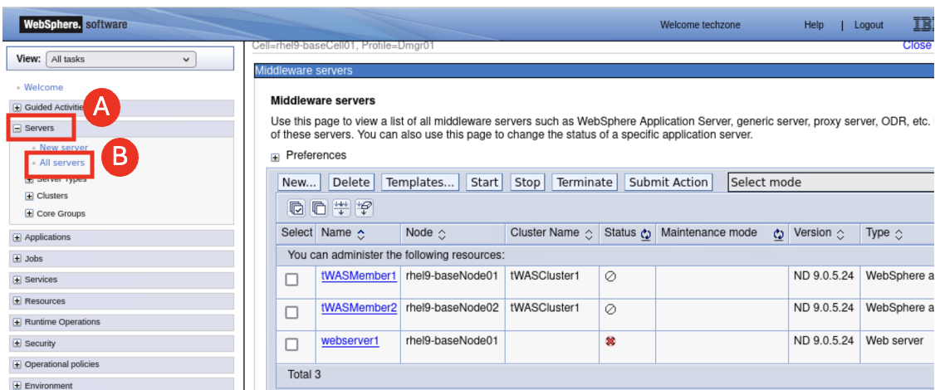

As you can see that there are two WAS 9.0.5.24 servers and one IHS 9.0.5.24 server are listed.

* 1. Stop the Deployment Manager with command:

cd /home/techzone/IBM/WebSphere/AppServer/profiles/Dmgr01/bin

./stopManager.sh -username techzone -password IBMDem0s!

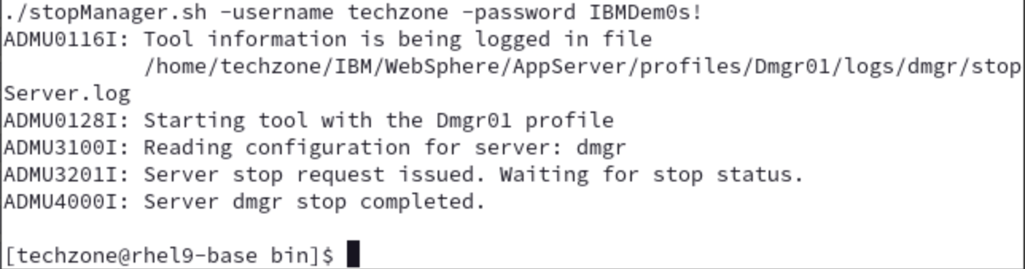

1. Install Liberty and MoRE through IBM Installation Manager.
   1. In the **terminal** window issue the following command to launch **IBM Installation Manager.**

/home/techzone/IBM/InstallationManager_Group/eclipse/IBMIM

* 1. In the IBM Installation Manager page, click **Install (A)**.

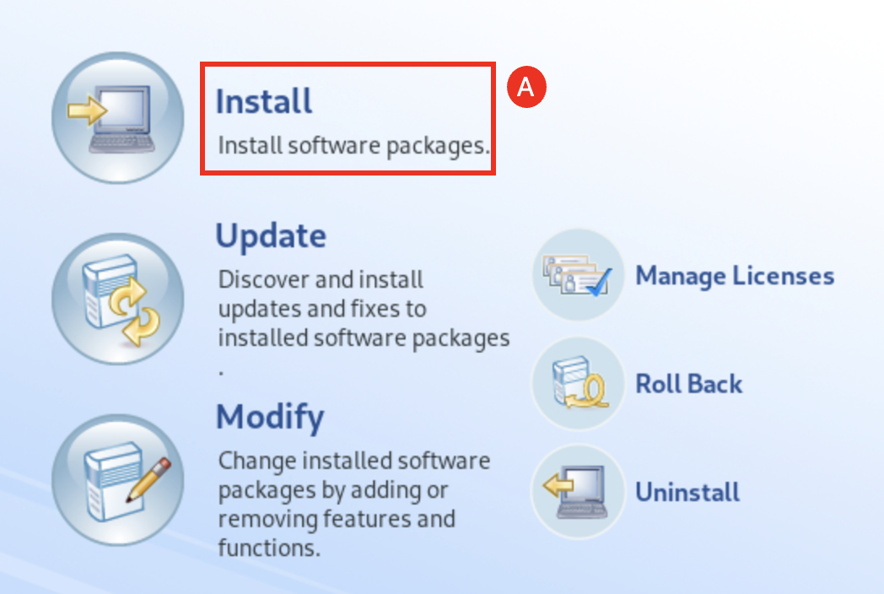

* 1. In the Install Packages page, check the **IBM WebSphere Application Server Liberty Network Deployment box (A**), check the **IBM Semeru Runtime Certified Edition Version 17 box (B)** and the **IBM Modernized Runtime Extension for Java (MoRE) box (C)**, then click **Next (D)**.

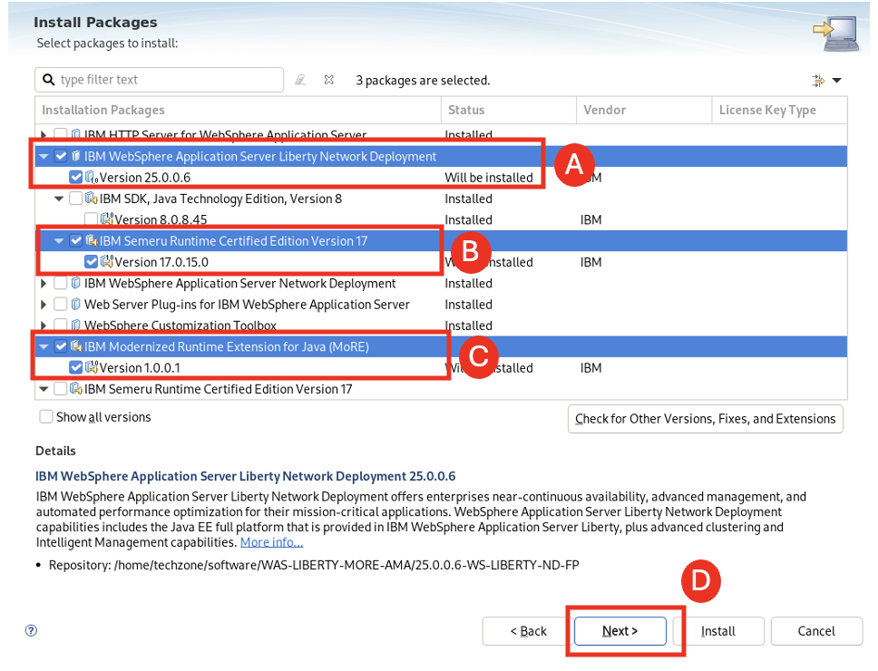

* 1. Accept the license agreement by selecting its **option button (A)** and click **Next (B)**.

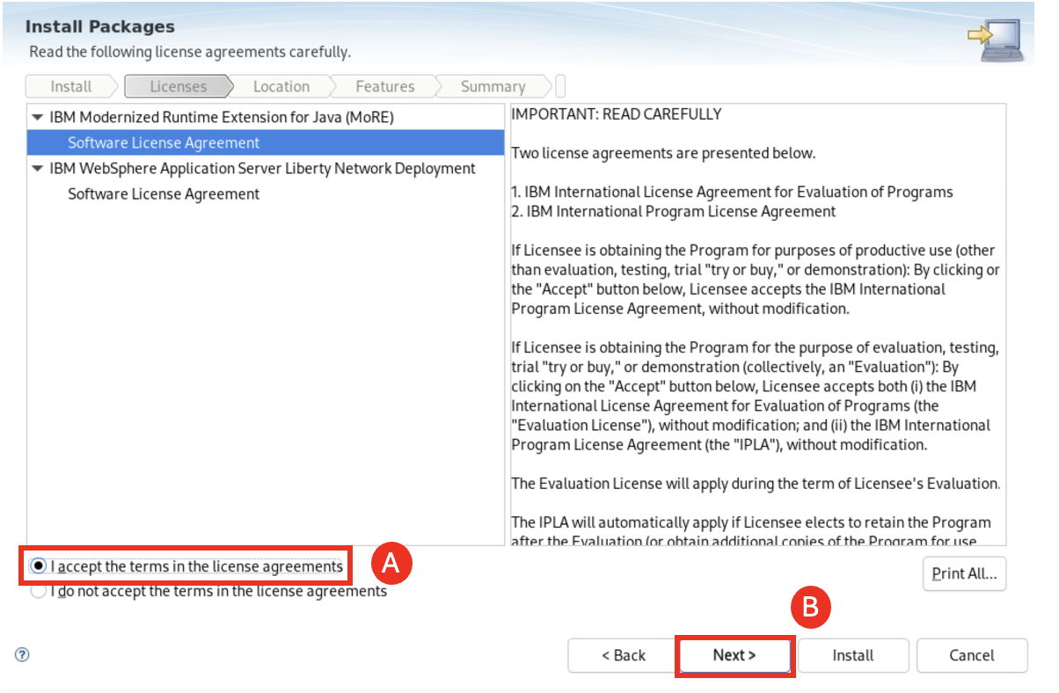

* 1. Accept the default installation directories and click Next (A).

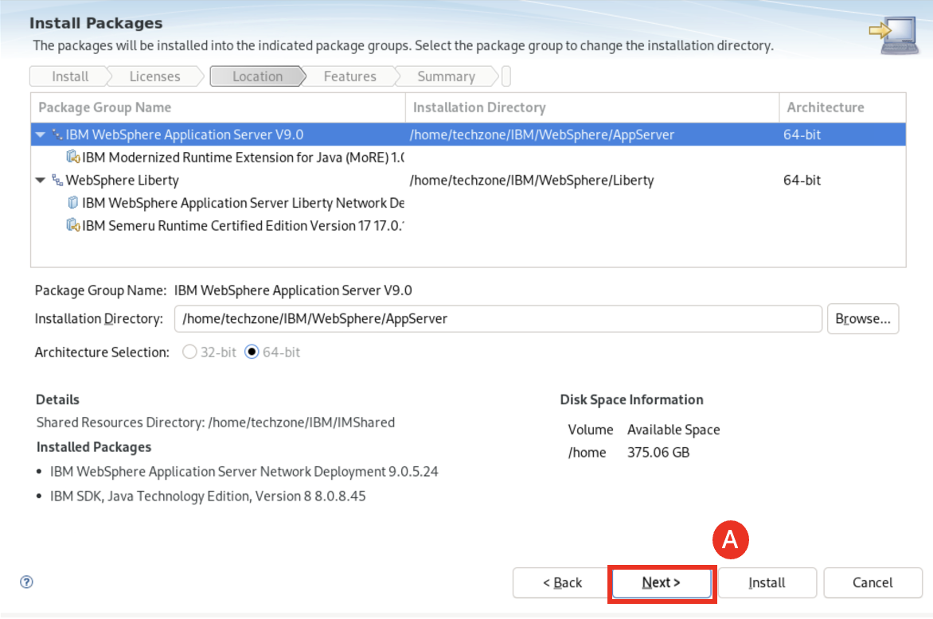

* 1. Click **Next (A)**.

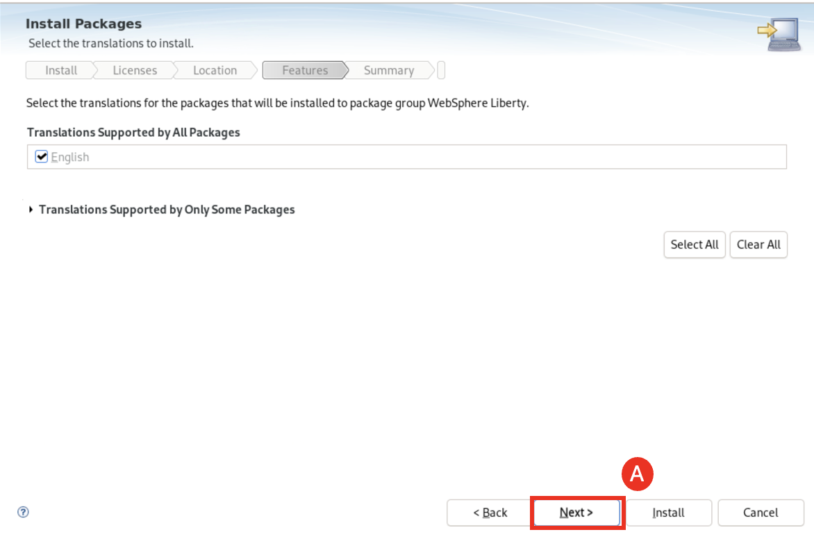

* 1. Accept the Recommended Installation option and click **Next (A)**.

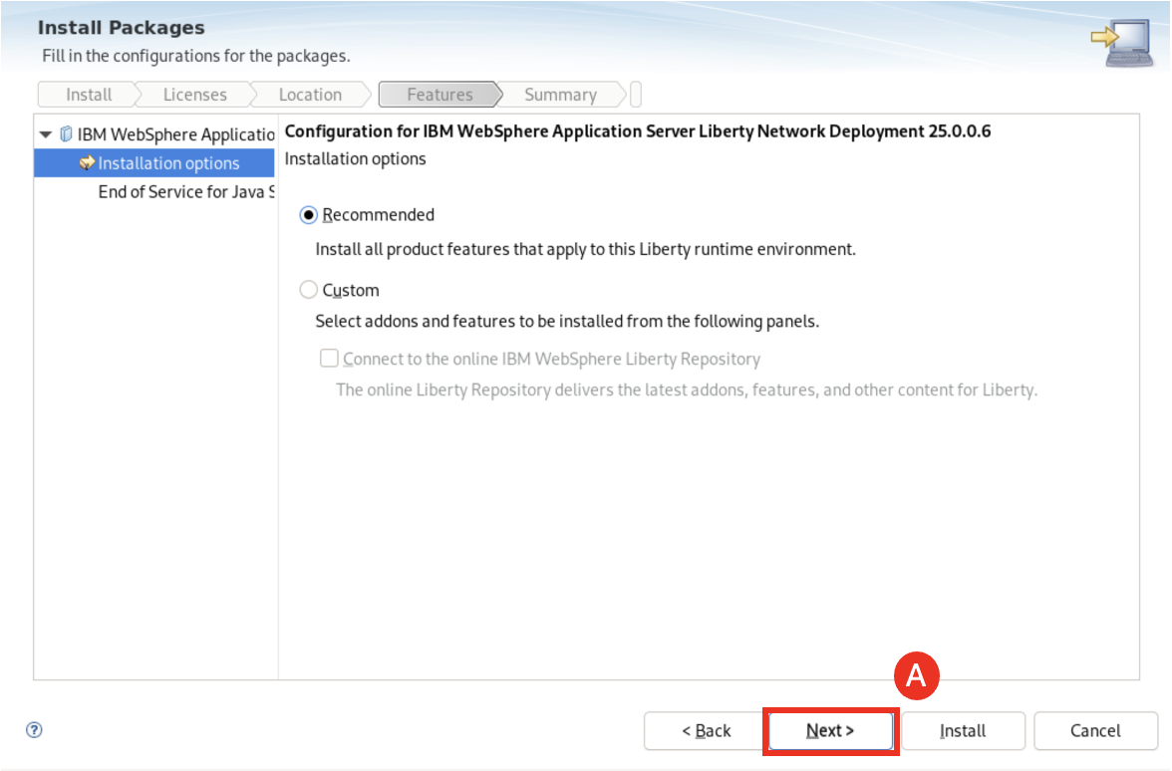

* 1. Click **Next (A)**.

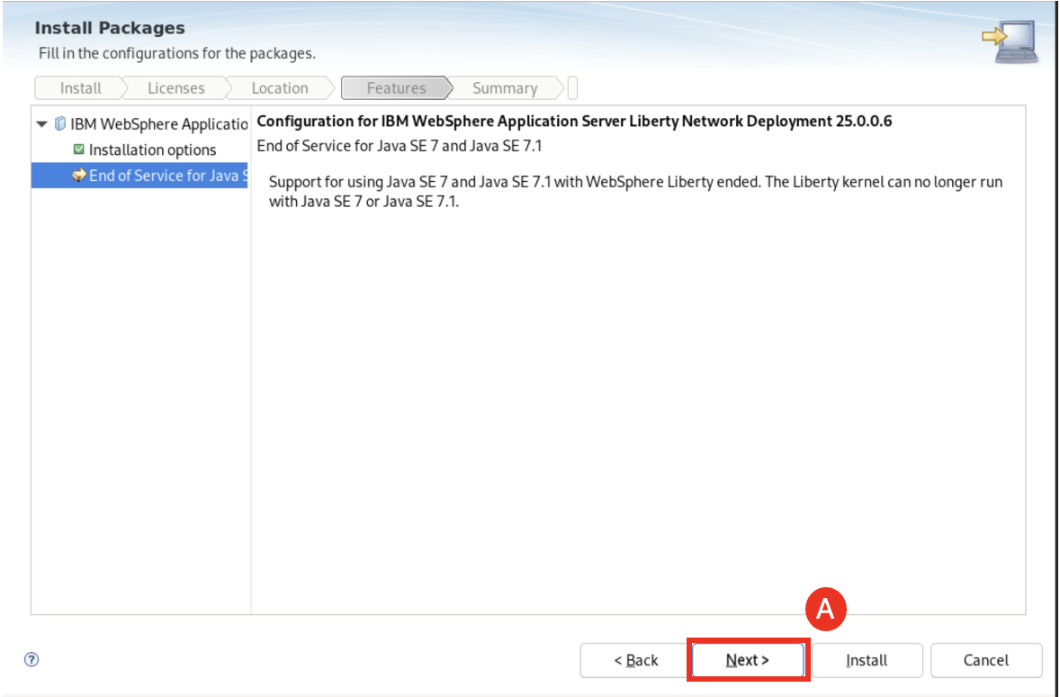

* 1. Click **Install (A)**.

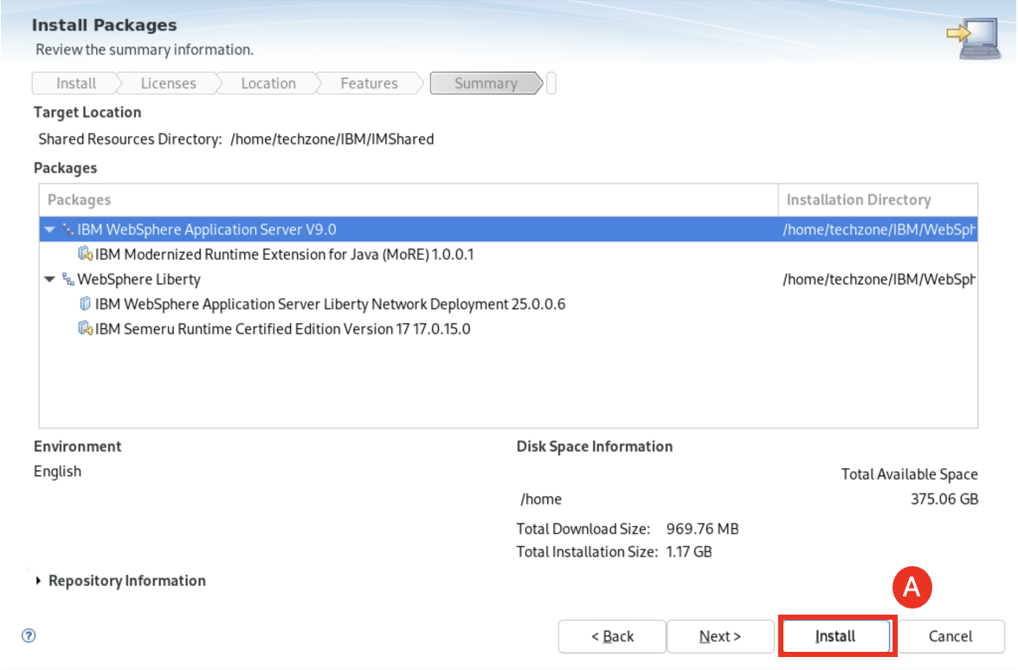

This kicks off the installation process. After a few minutes the installation is completed.

* 1. Click **Finish (A)** and exit the Installation Manager.

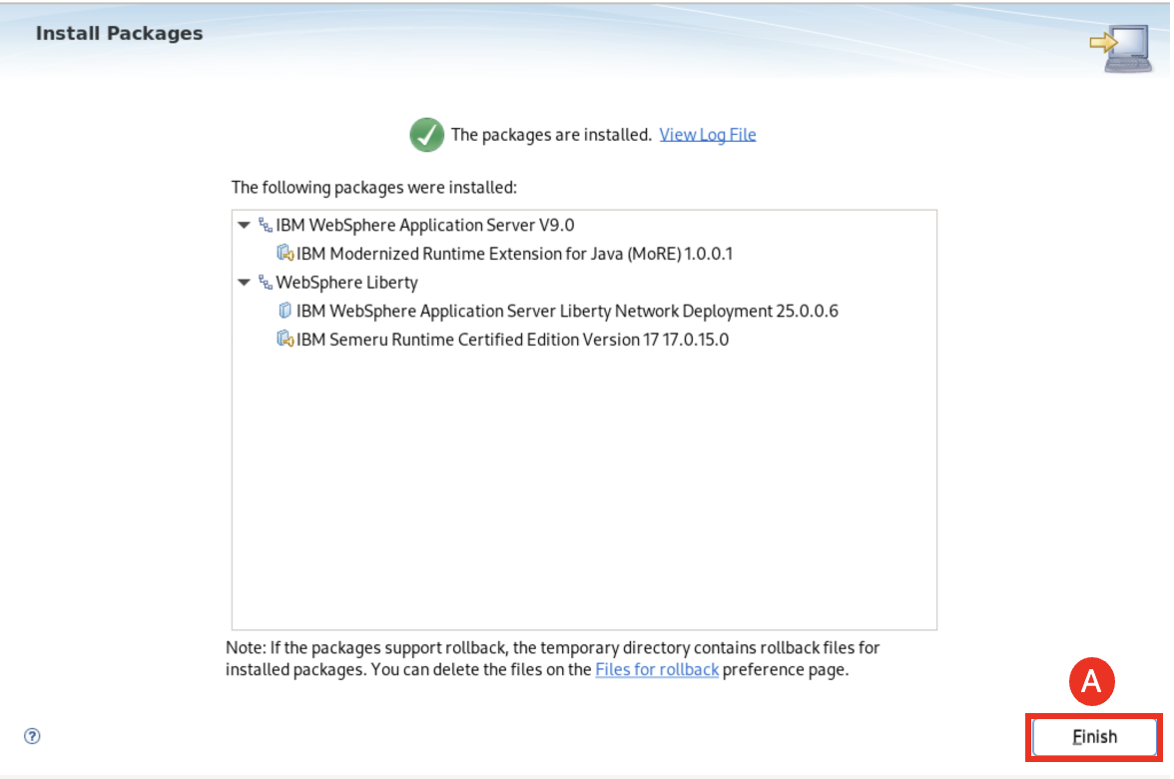

1. Enable command assistance and log command assistance in WAS Admin Console.

**Note:** This configuration is needed to generate the wsadmin command assistance for UI driven tasks.

* 1. Start the WebSphere Application Network Deployment (WAS ND) environment with commands:

cd /home/techzone/IBM/WebSphere/AppServer/profiles/Dmgr01/bin

./startManager.sh

cd /home/techzone/IBM/WebSphere/AppServer/bin

./startNode.sh -profileName AppSrv01

./startNode.sh -profileName AppSrv02

* 1. Go to the WAS Admin Console page in web browser with URL: **https://localhost:9043/ibm/console.**
  2. In the console page, navigate to: **System administration (A)** **>** **Console preferences (B)**.

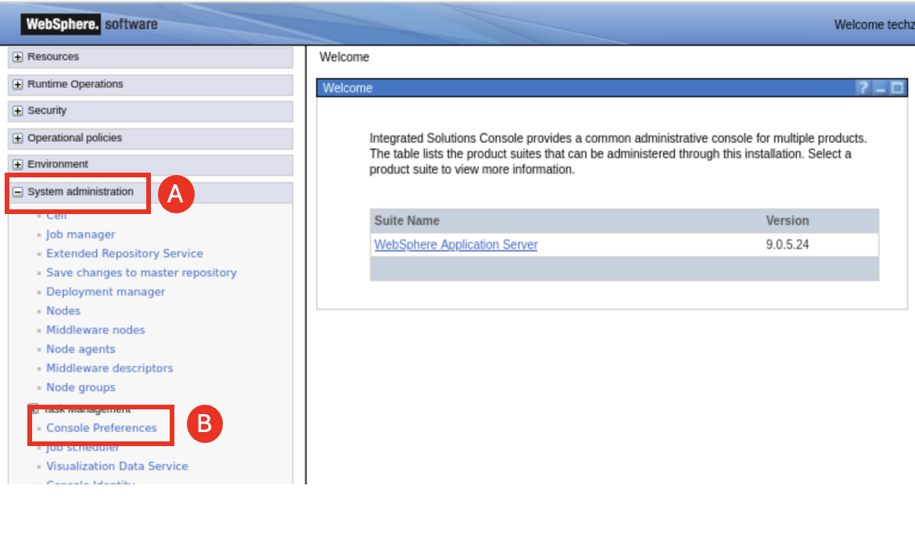

* 1. Select the following options and click **Apply (C)**:
     + **Enable command assistance notifications (A)**
     + **Log command assistance commands (B)**

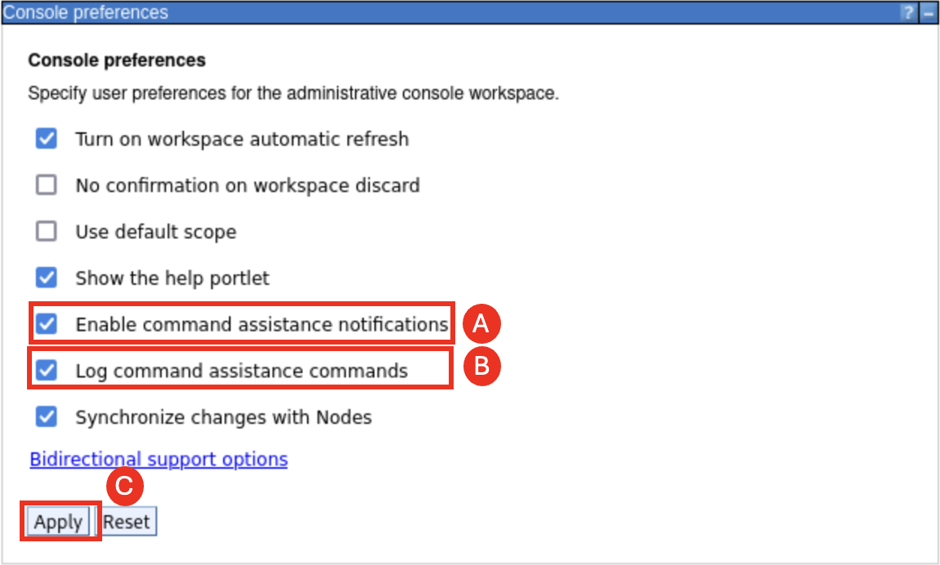

1. View the WebSphere nodes where the managed Liberty Servers / Cluster will be deployed
   1. Navigate to **System administration (A)** > **Nodes (B)**.

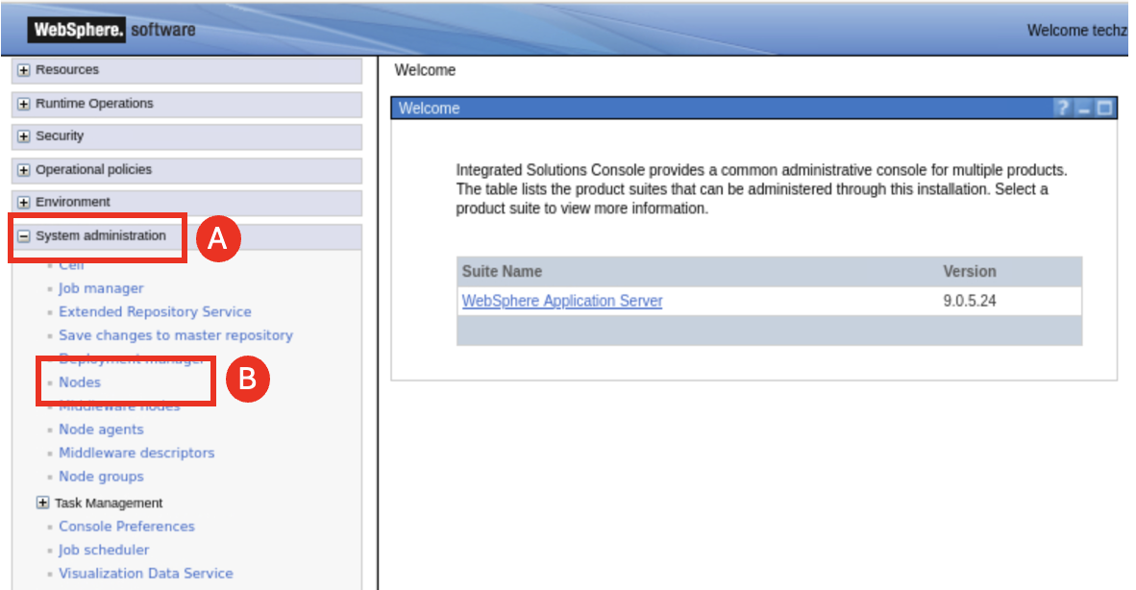

The Deployment Manager, Node01 and Node02 are all on the same VM in this lab environment and share the same application server binaries. In a distributed environment, you would need to install MoRE on each node where the MoRE capabilities are required, which includes also the Deployment Manager.

Both nodes have **MoRE** installed, which is required to run “Managed Liberty Servers” on the nodes.

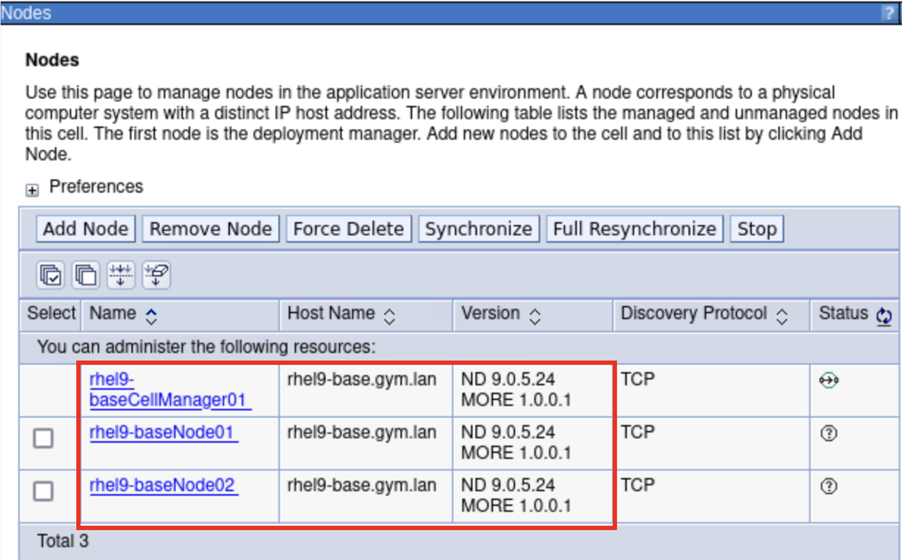

1. Create a static WebSphere cluster of two managed Liberty Servers, one on each of the two nodes.
   1. Navigate to **Servers (A)** > **Clusters (B)** > **WebSphere application server clusters (C)**.

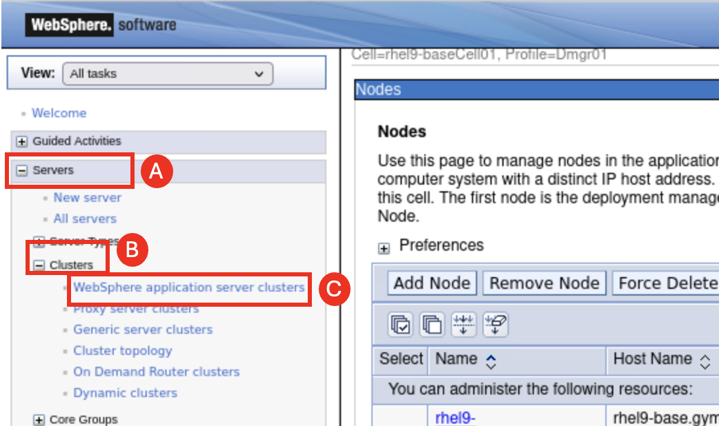

* 1. Click **New (A)** to start the “create cluster” wizard.

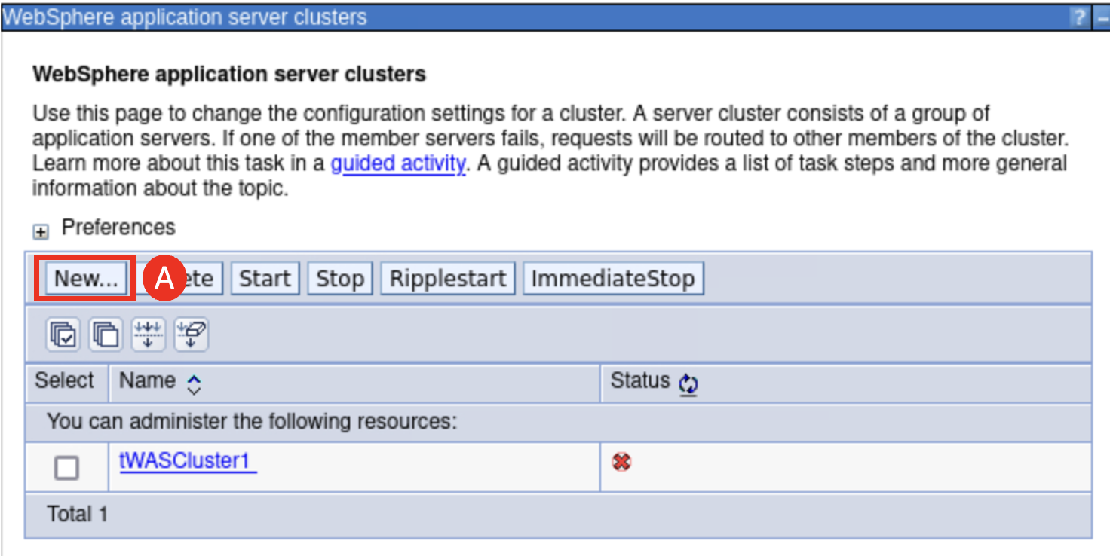

* 1. Step 1, set Cluster name to **MLSCluster (A)**. Leave the other fields as default and click **Next (B)**.

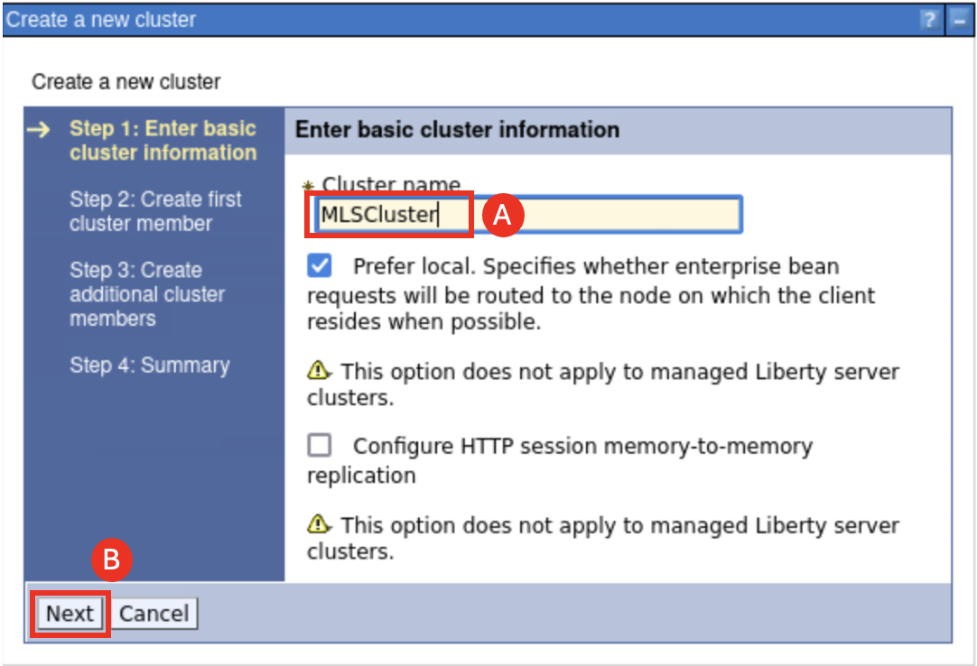

* 1. Step 2, configure the first cluster member with the following values and click **Next (D)**.

Member Name: **libertyServer1 (A)**

Select node: **rhel9-BaseNode01 (B)**

Select **Create the member using an application server template** and **default-managed-liberty-server** (**C)**

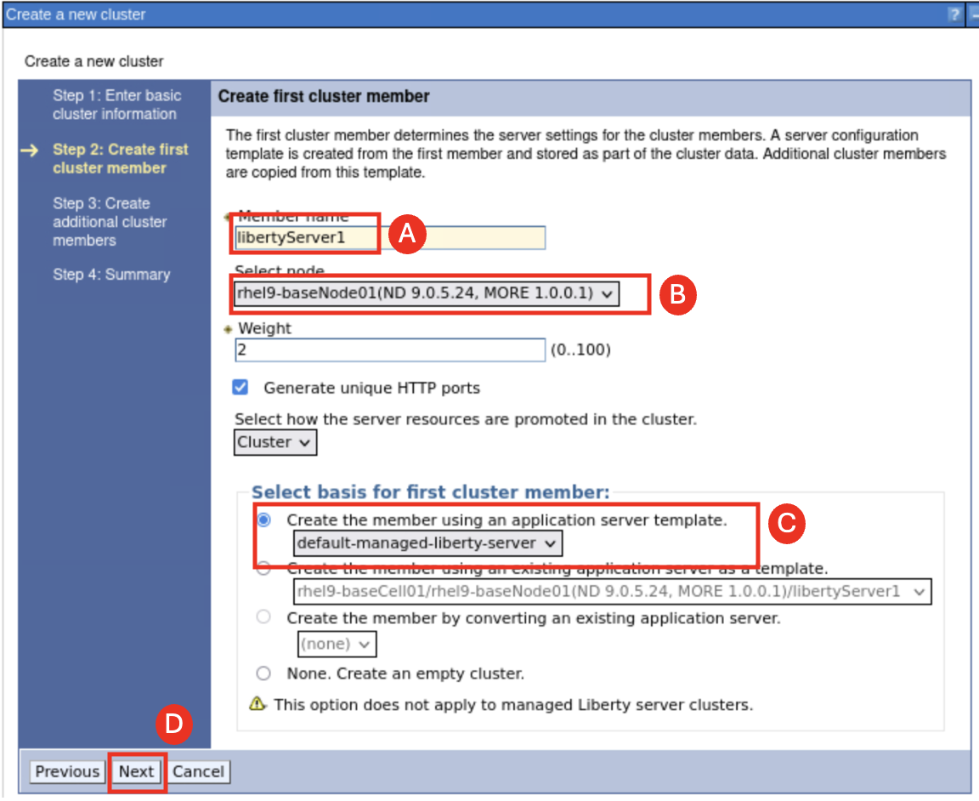

* 1. Step 3, configure the second cluster member with the following values and click **Add Member (C)**:

Member Name: **libertyServer2 (A)**

Select node: **rhel9-BaseNode02 (B)**

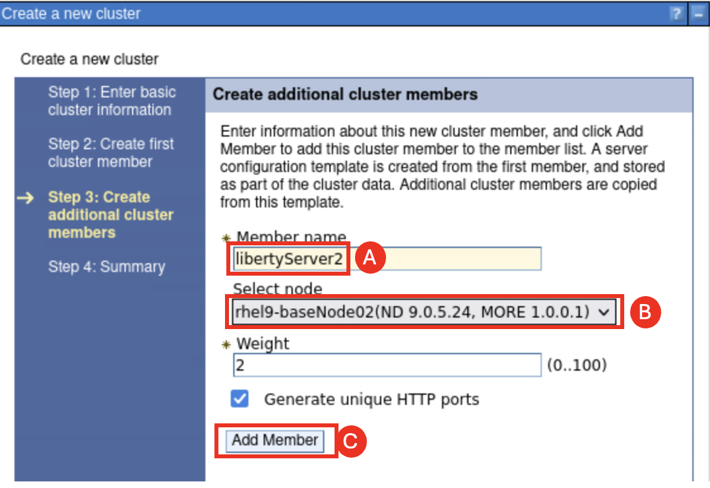

* 1. Check to make sure that the versions of **libertyServer1** and **libertyServer2** are **LIBERTY 25.0.0.6** and click **Next (A)**.

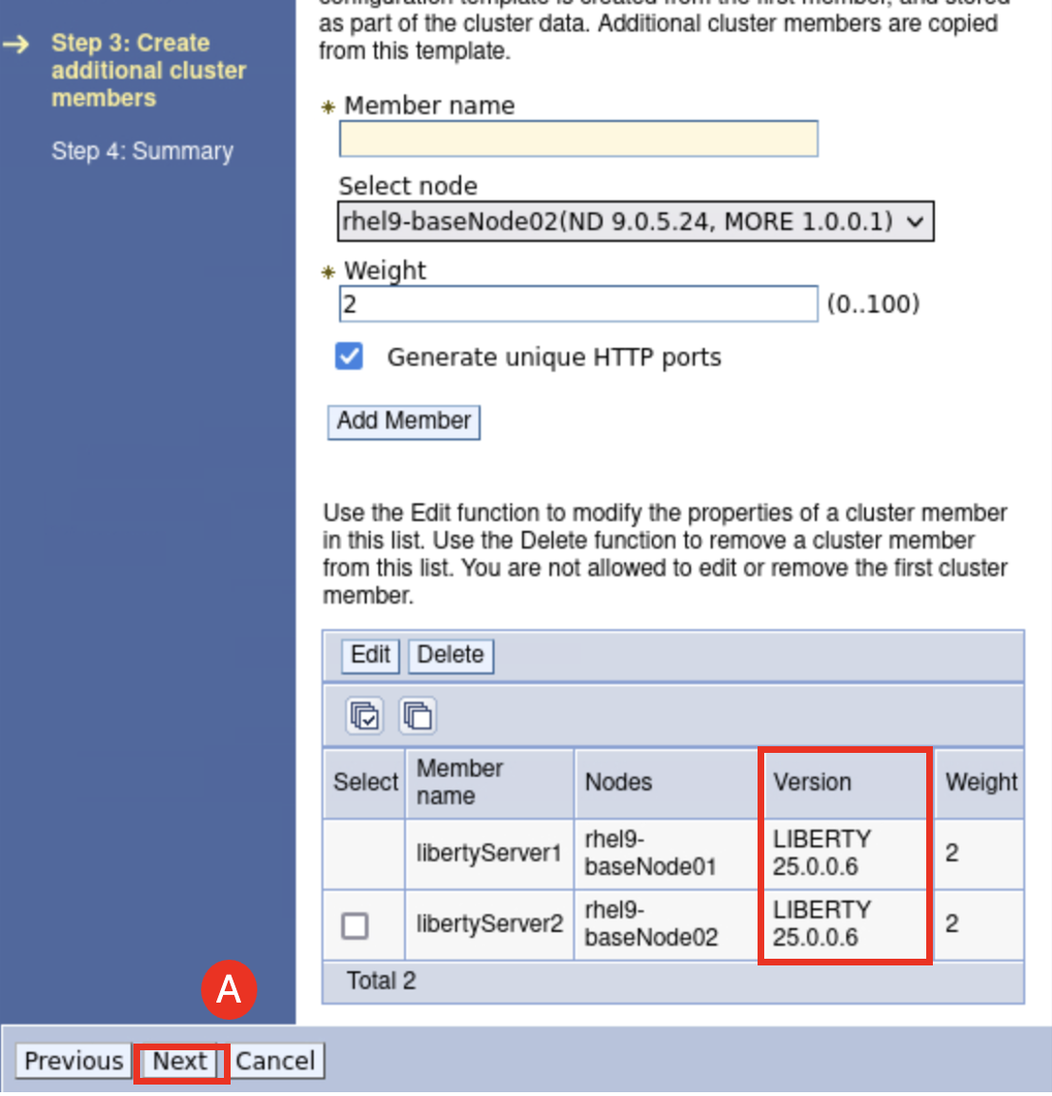

* 1. Step 4, Review the configuration summary and click **Finish (A)**.

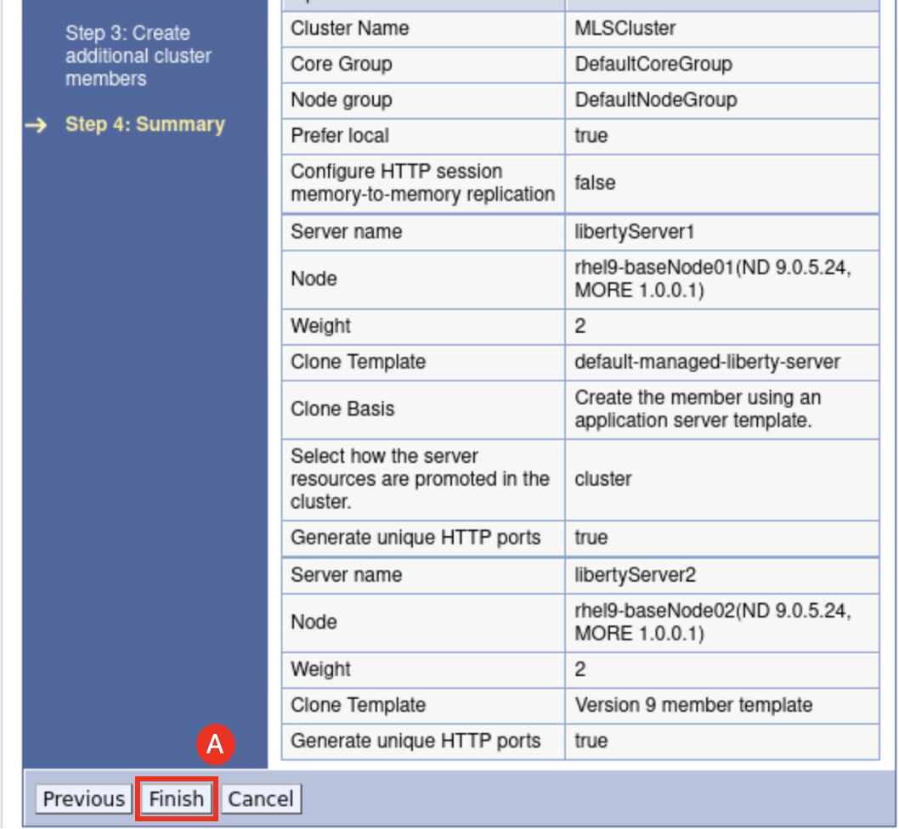

1. View the command assistance that displays the wsadmin commands that could be used to create the cluster.
   1. Click the “**View administrative scripting commands for last action”** **link (A),** located under the **Command Assistance** section on the right side of the pane

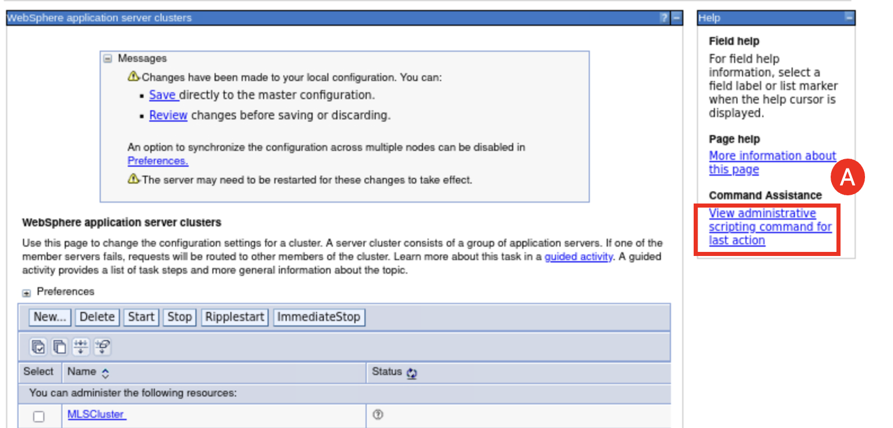

A new window is displayed that shows the wsadmin commands that will run to create the cluster.

The nice thing about this is that you can copy these commands and use them to build wsadmin scripts to automate the configuration for consistency and repeatability.

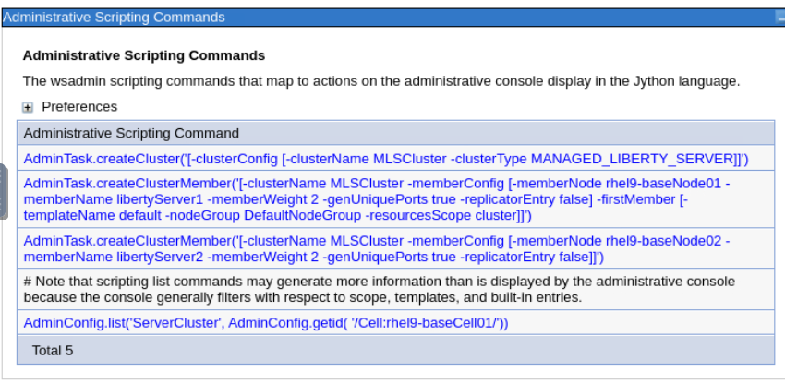

* 1. **Close** the command assistance window

1. **Save** the updates to the master configuration.
   1. Click **Save (A).**

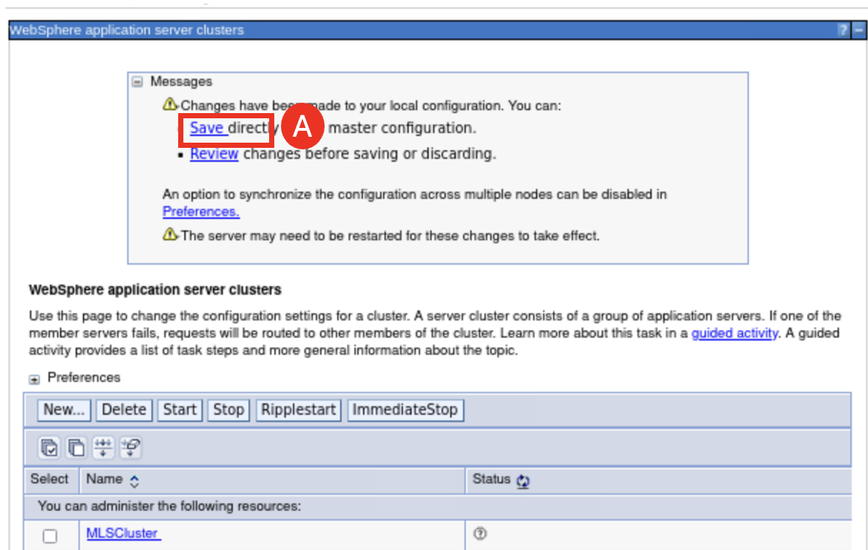

* 1. Wait until you see the message saying, “The configuration synchronization complete for cell.”, then click **OK (A)**.

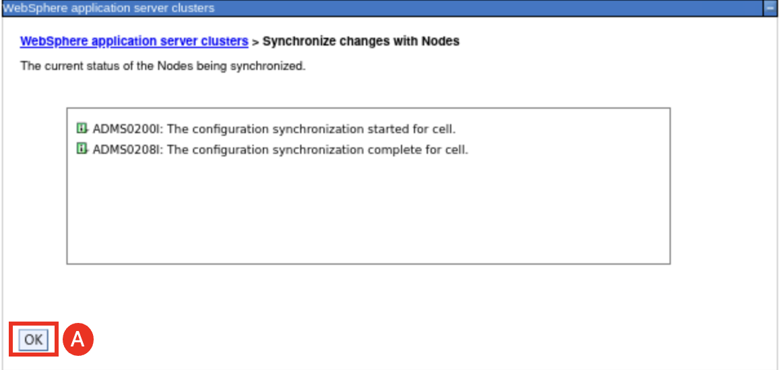

Now the changes have been synchronized and the **MLSCluster** is created.

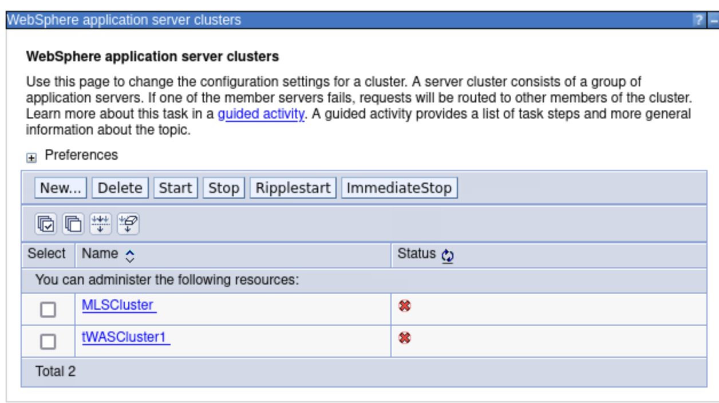

1. View and confirm the Liberty servers are defined in the **MLSCluster.**
   1. Navigate to **Servers (A)** > **Server Types (B)** > **WebSphere application servers (C)**.

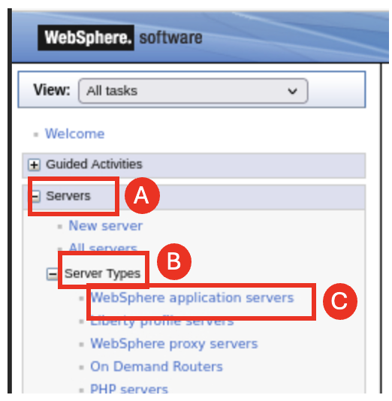

Note the **liberty servers** that are defined in the cluster named **MLSCluster**

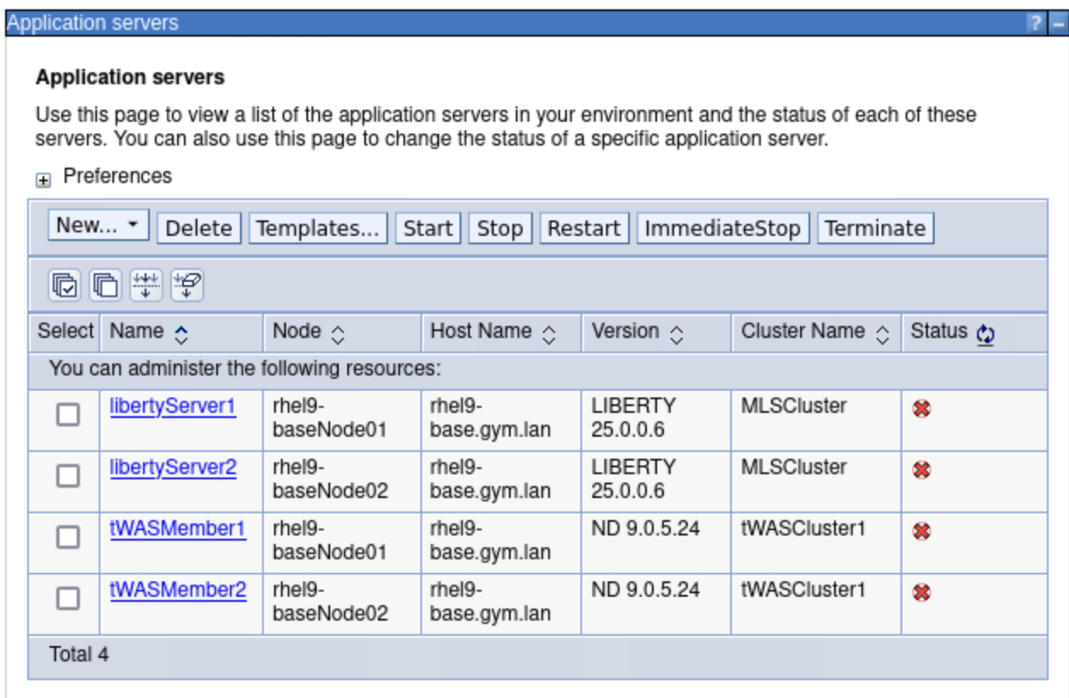

1. Install the **WhereAmI** Java 17 application into the **MLSCluster.**
   1. Navigate to **Applications (A)** > **New Application (B)**.

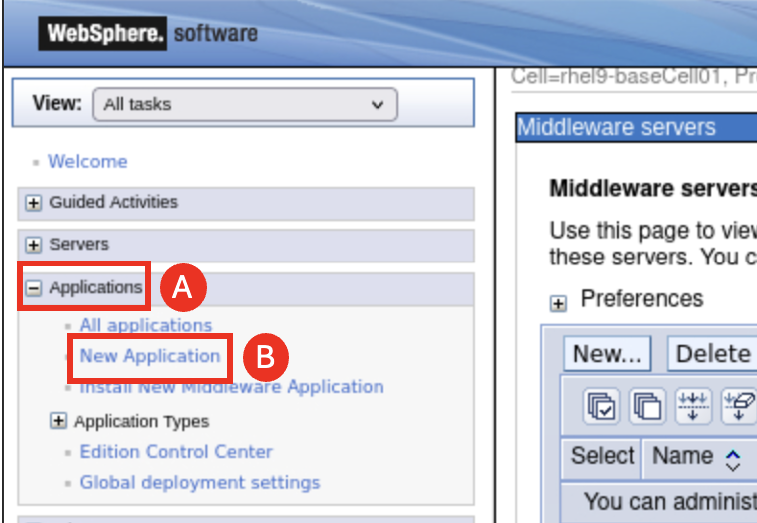

* 1. Click **New Enterprise Application (A)**.

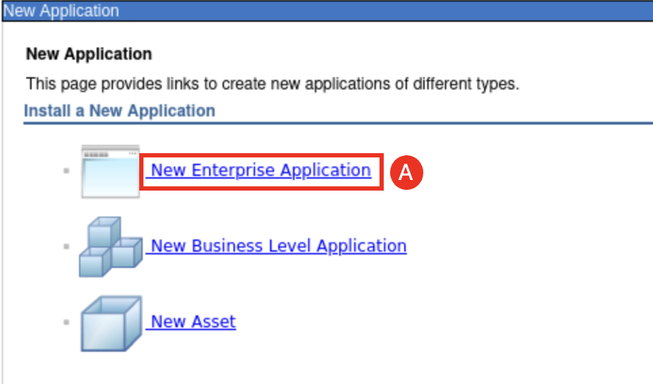

* 1. Under **Path to new application**, select **Local file system (A)** and click **Browse… (B)**.

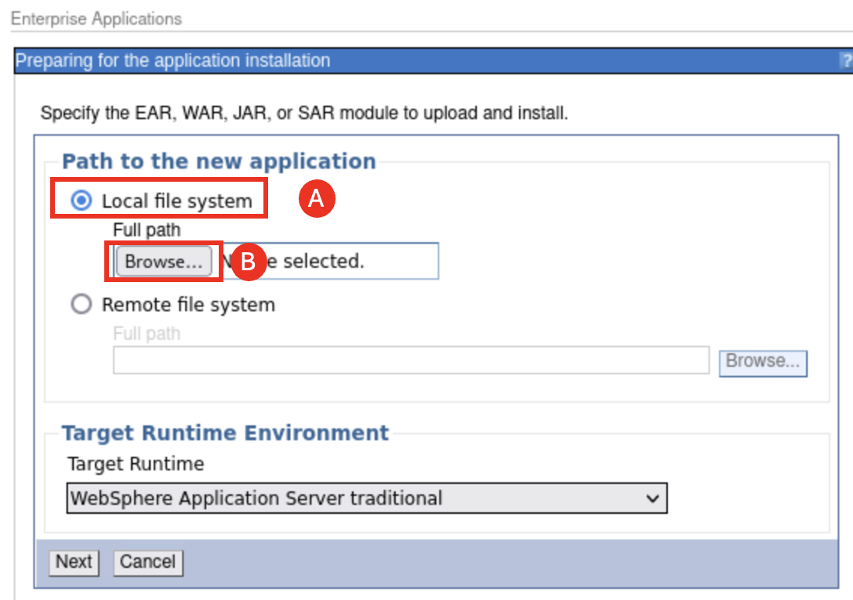

* 1. If you have completed the IBM Application Modernization Accelerator (AMA) lab in this lab environment, you can navigate to **/home/techzone/demos/AMA/WhereAmI-2.0.0-Project/WhereAmI/target** directory, select **WhereAmI-2.0.01.war file (A)** and click **Open (B)**.

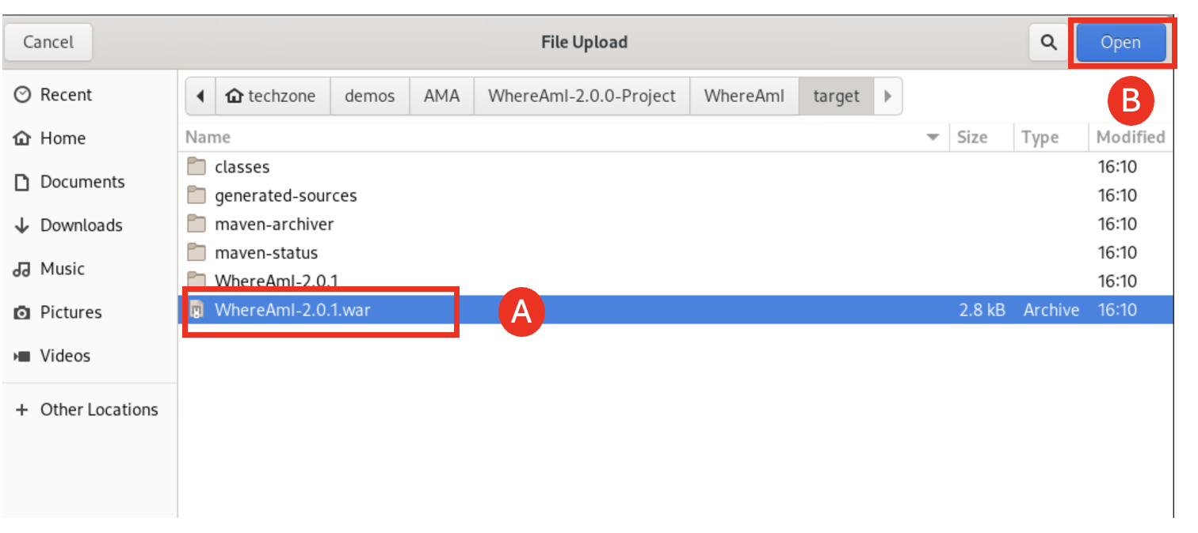

Otherwise, you can navigate to **/home/techzone/demos/ManagedLiberty-MoRE** directory, select **WhereAmI-2.0.01.war file (A)** and click **Open (B)**.

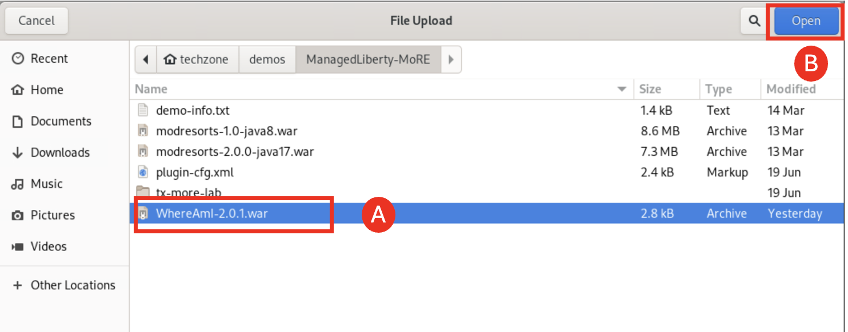

* 1. Set Target Runtimeto **WebSphere Liberty (A)** and click **Next** (B).

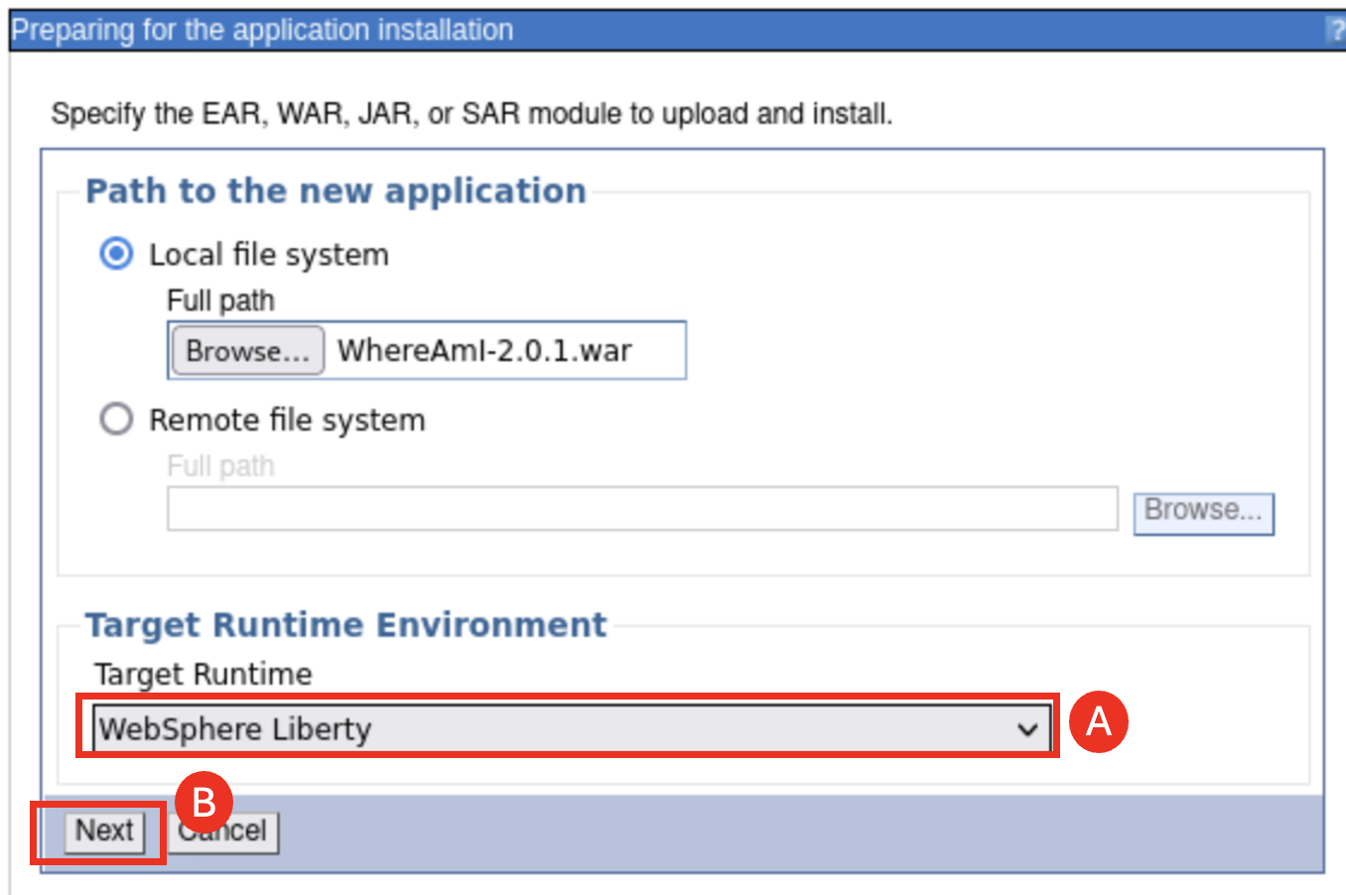

* 1. Select **Fast Path (A)** and click **Next (B)**.

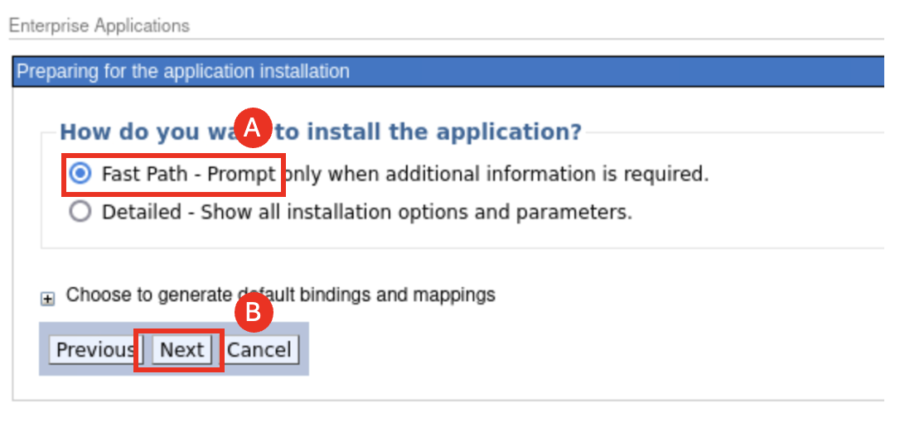

* 1. Leave **Step 1** unchanged and click **Next (A)**.

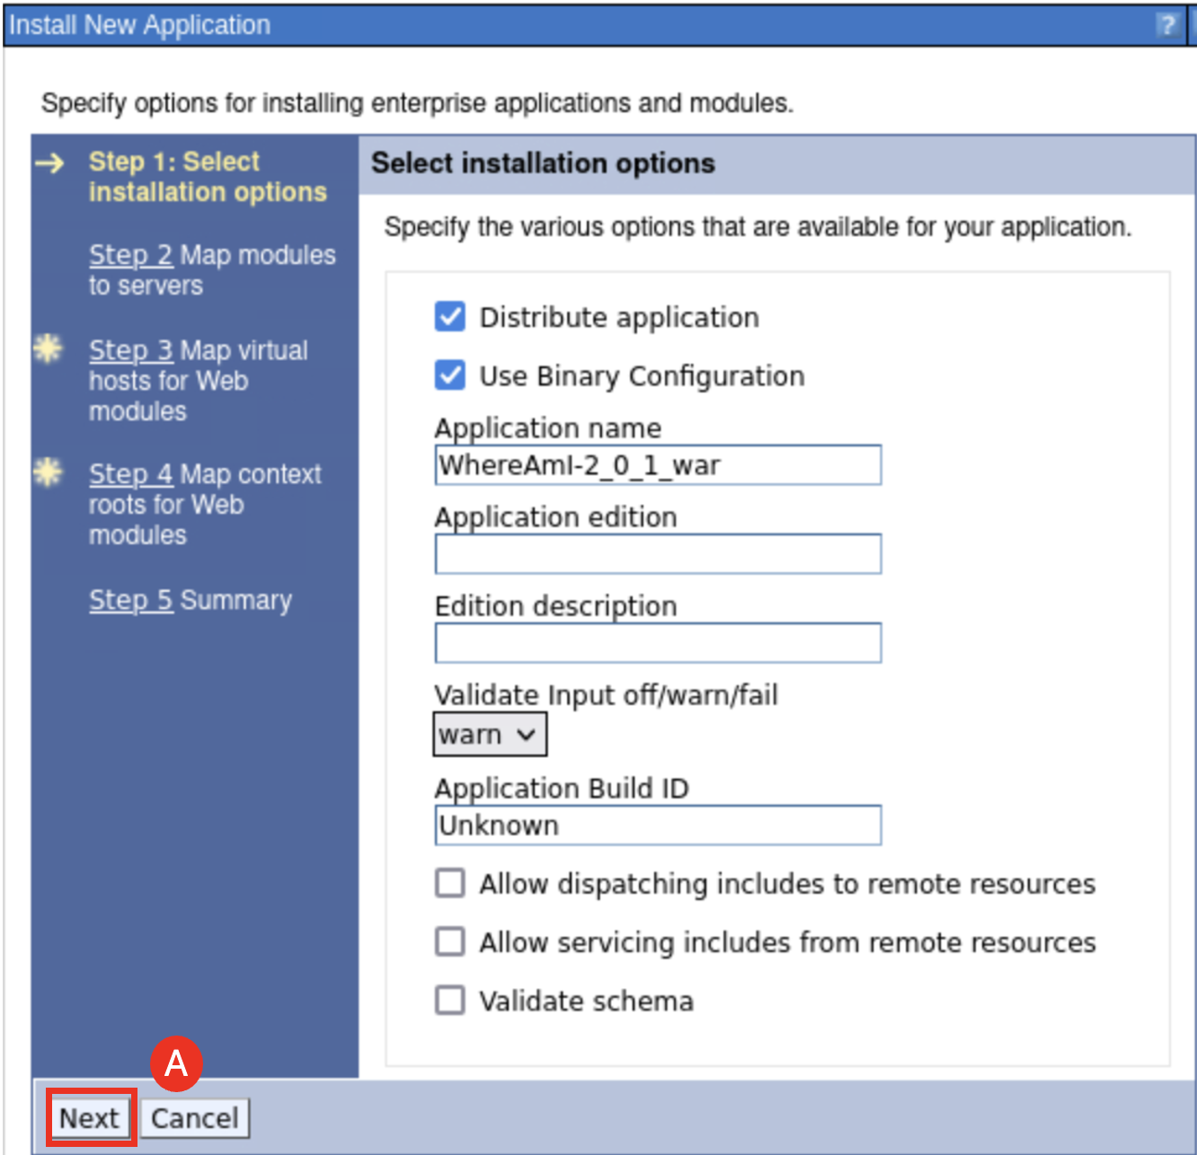

* 1. On **Step 2**, map the application module by checking the **box next to modresorts-2.0.0.war (A),** selecting both **MLSCluster** and **webserver1 (B)** under **Cluster and servers**, and clicking **Apply** (C)

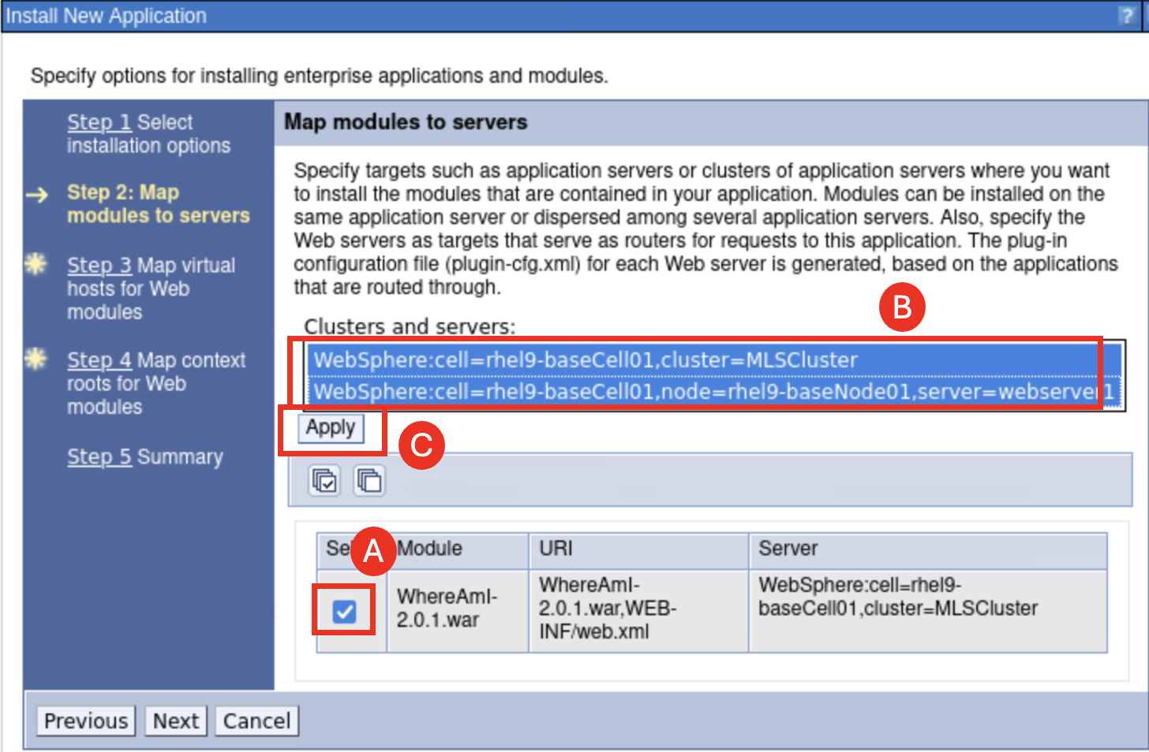

* 1. The **MLSCluster** and **webserver1**  servers are added to the Module Server list, click **Next (A)**.

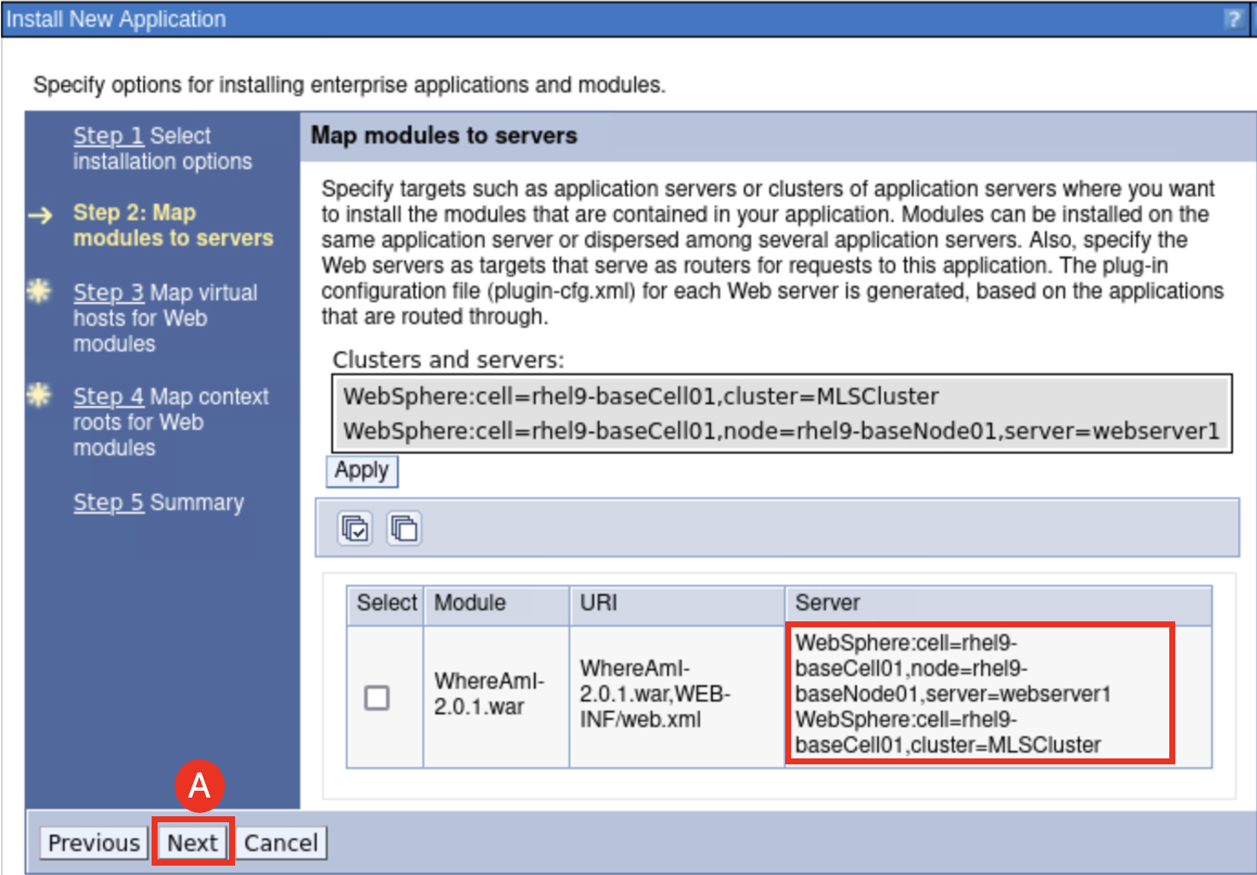

* 1. On **Step 3**, click **Next (A)**.

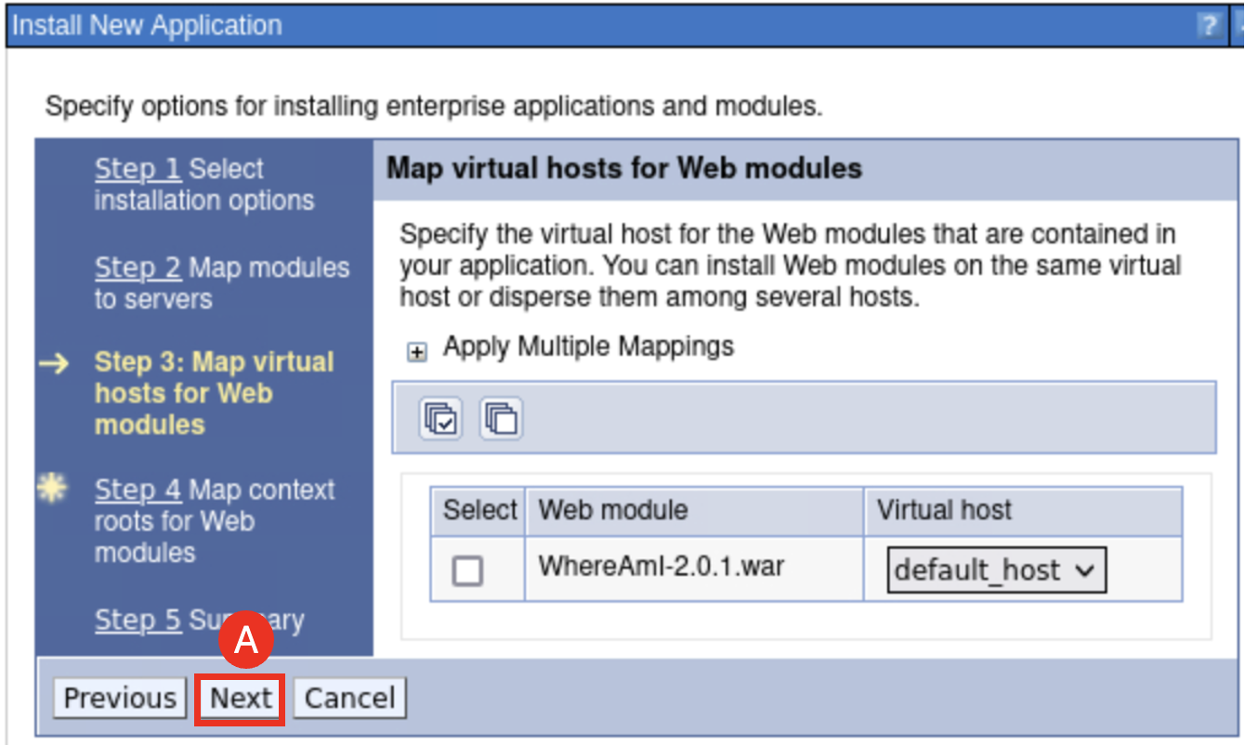

* 1. On Step 4, Set **Context Root** as **/Liberty (A)** and click **Next (B)**.

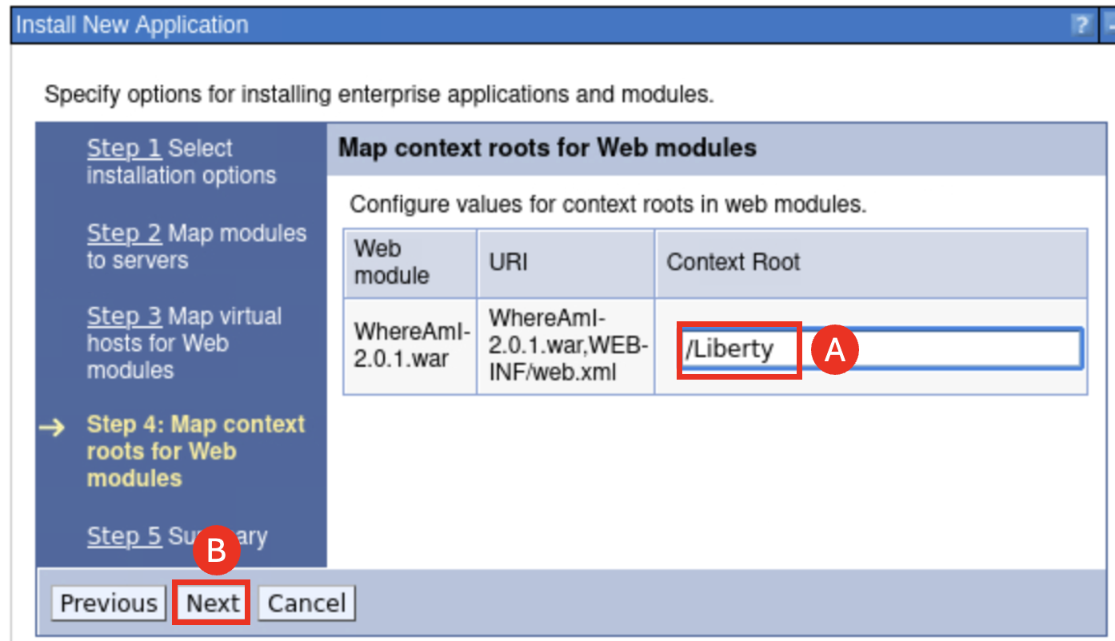

* 1. View the command assistance that displays the wsadmin commands that could be used to install the application by click the View administrative scripting commands for **last action link (A)**, located under the **Command Assistance** section on the right side of the pane.

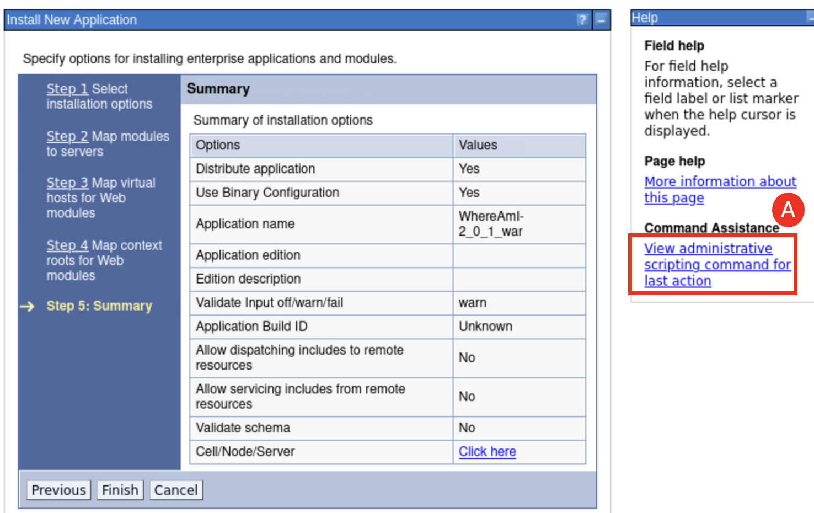

The wsadmin command to install the WhereAmI application is displayed.

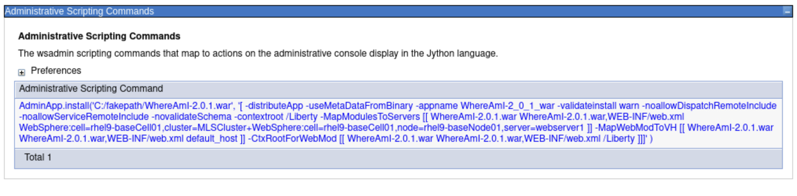

* 1. Click **Finish (A)** on the Installation summary page, which will install the application.

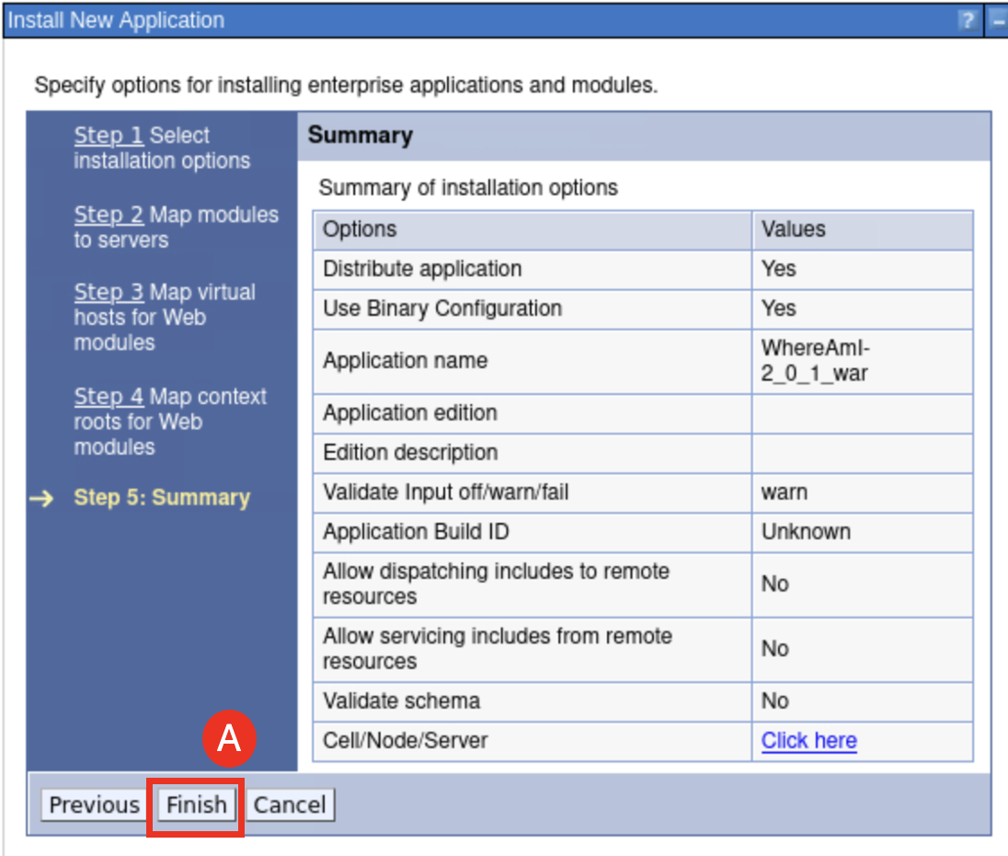

* 1. After the installation is completed, click **Save** **(A)**.

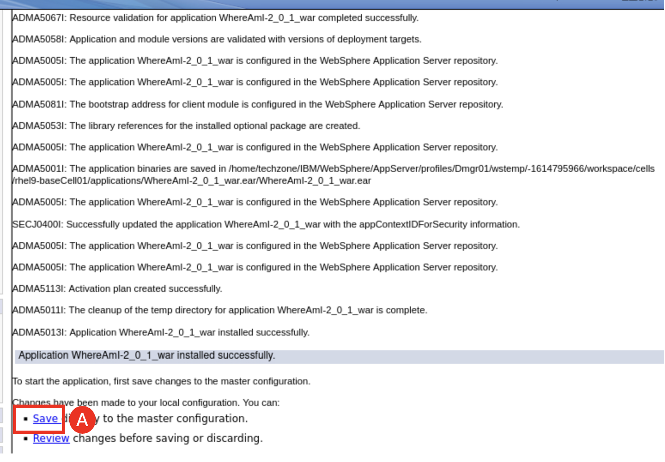

* 1. Wait for the message box to display the messages stating the configuration has been successfully synchronized, then click **OK (A)**.

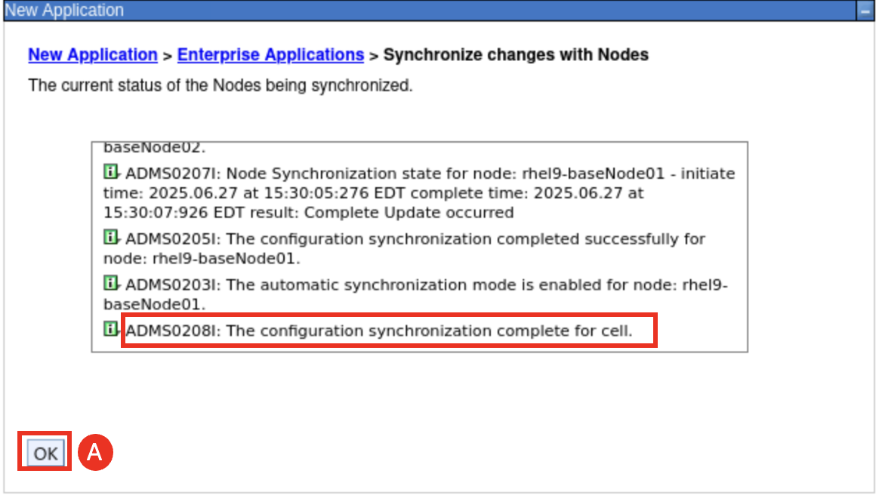

The application is now installed into the managed Liberty Servers in the **MLSCluster**.

1. View the application and see that it is installed on the **MLSCluster** of Liberty servers.
   1. Navigate to **Applications (A)** > **Application Types (B)** > **WebSphere enterprise applications** **(C)**.

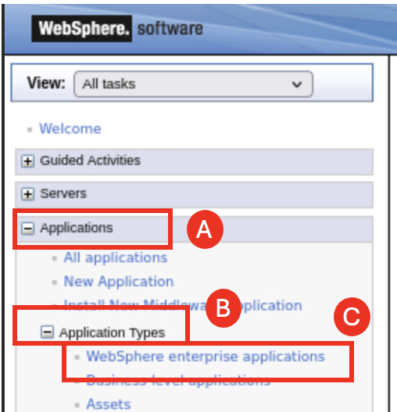

* 1. Click the **WhereAmI-2.0.1_war (A)** that is shown in the list of applications

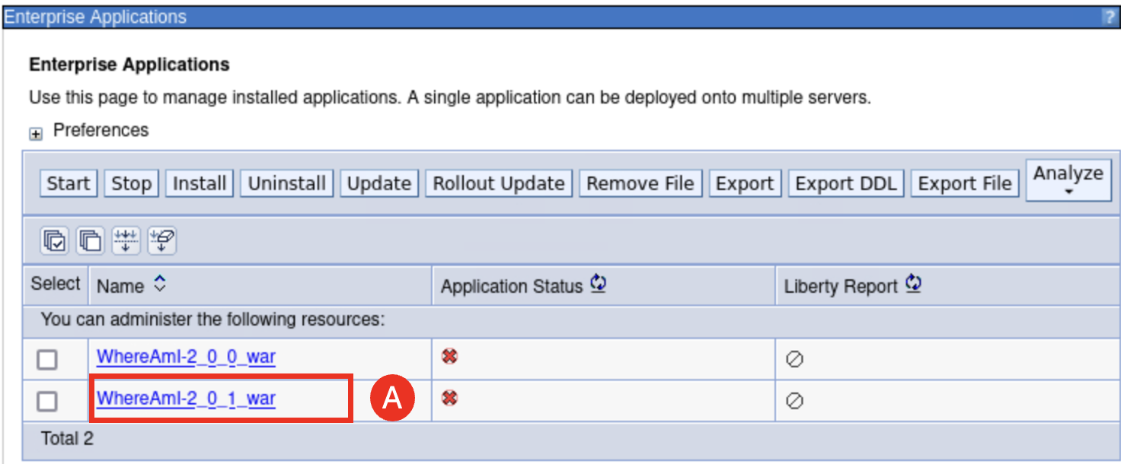

* 1. Click **Manage Modules (A)** under the **Modules** section on the **General Properties** page.

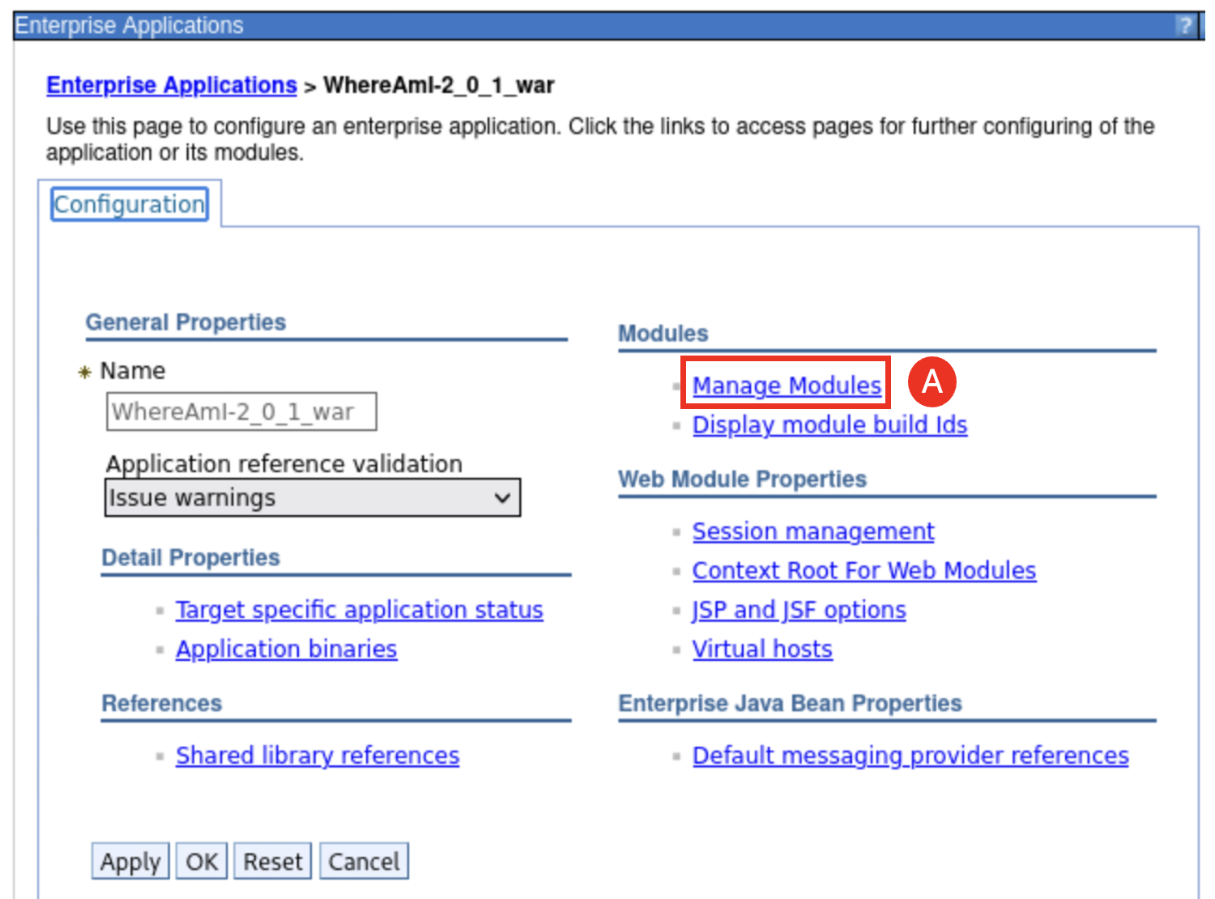

* 1. You can see that the application is mapped to the **MLSCluster** and the IBM HTTP Server **webserver1** as shown below. Click **Cancel (A)**, do not make any changes to the configuration.

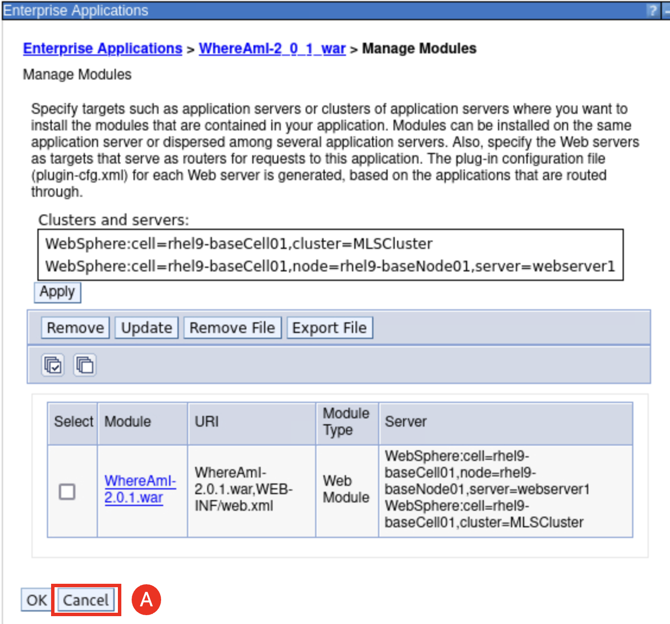

1. Start the servers in the **MLSCluster**.
   1. Go to the WebSphere Integration Solutions Console and navigate to **Servers (A)** > **Clusters (B)** > **WebSphere application server clusters (C).**

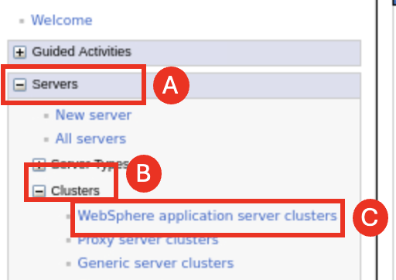

* 1. Select the checkbox next to **MLSCluster** (**A)** and click **Start (B)**.

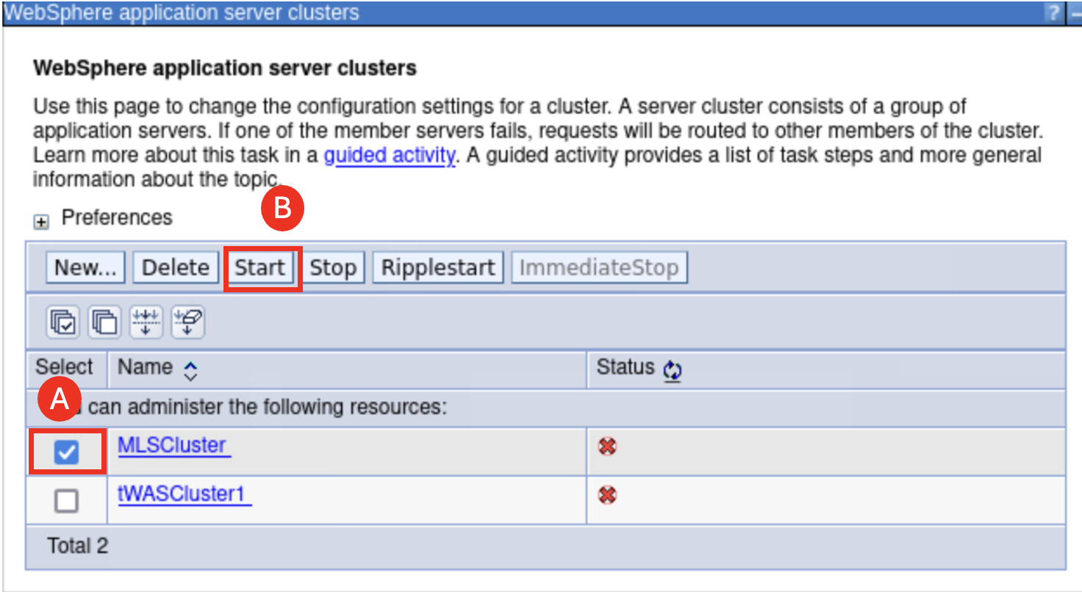

1. Verify the Liberty servers are running.
   1. Navigate to **Servers** > **Server Types** > **WebSphere application servers**, and you can see that the two Liberty servers are running.

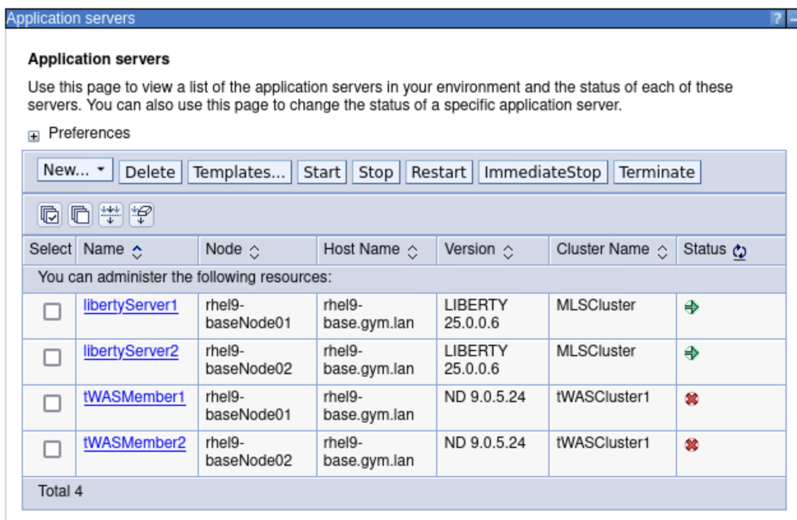

1. After the **MLSCluster** is started, you can access the installed application through the Liberty server ports.
   1. From the WAS Admin Console navigate to **Servers** > **Server Types** > **WebSphere application servers** and click **libertyServer1 (A)**.

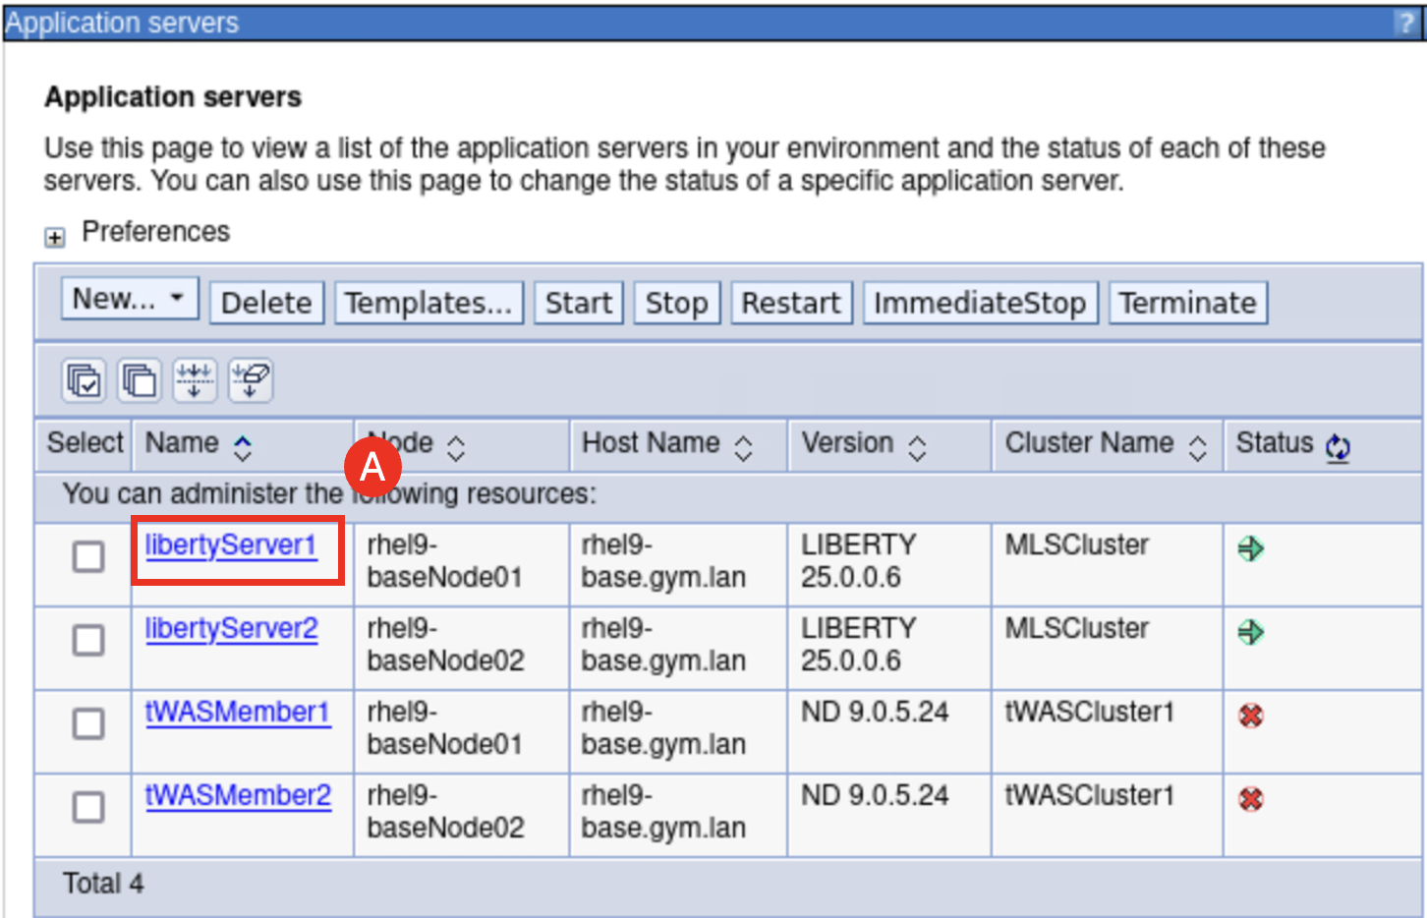

* 1. Click **Ports (A)**.

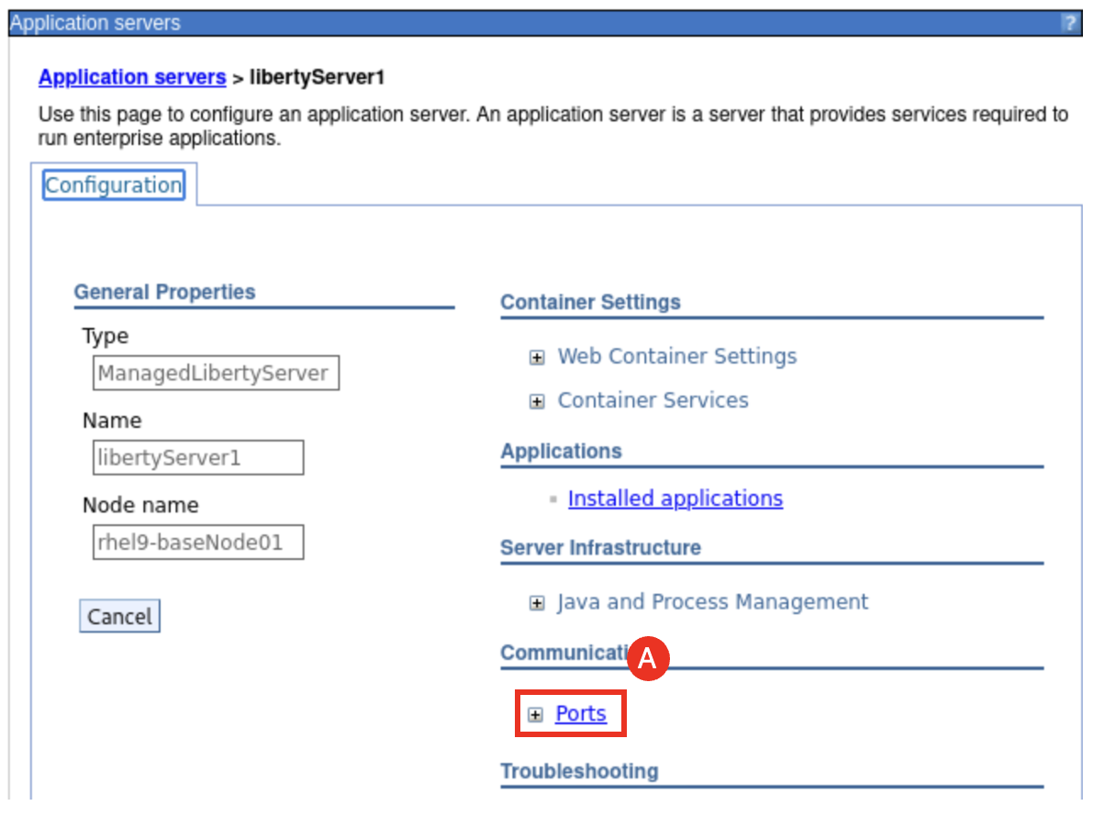

* 1. Identify the HTTP port, which is **9084** in the screenshot below (your port number might be different).

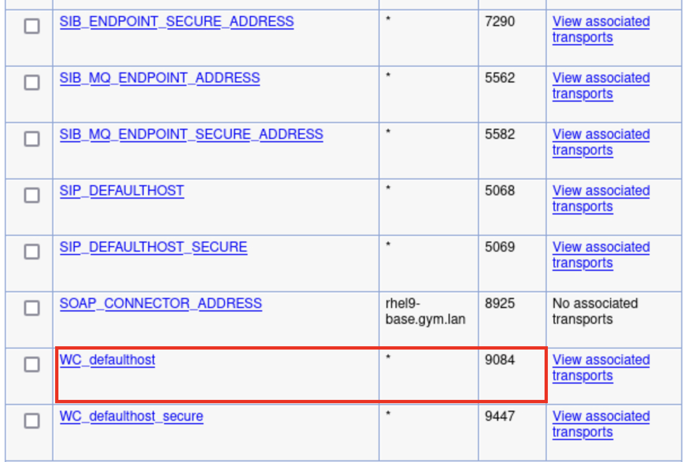

* 1. Open a new browser tab browser in the lab environment and navigate to the **WhereAmI** application using the context root **“/Liberty**”: **http://localhost:9084/Liberty/WhereAmI (A)**.

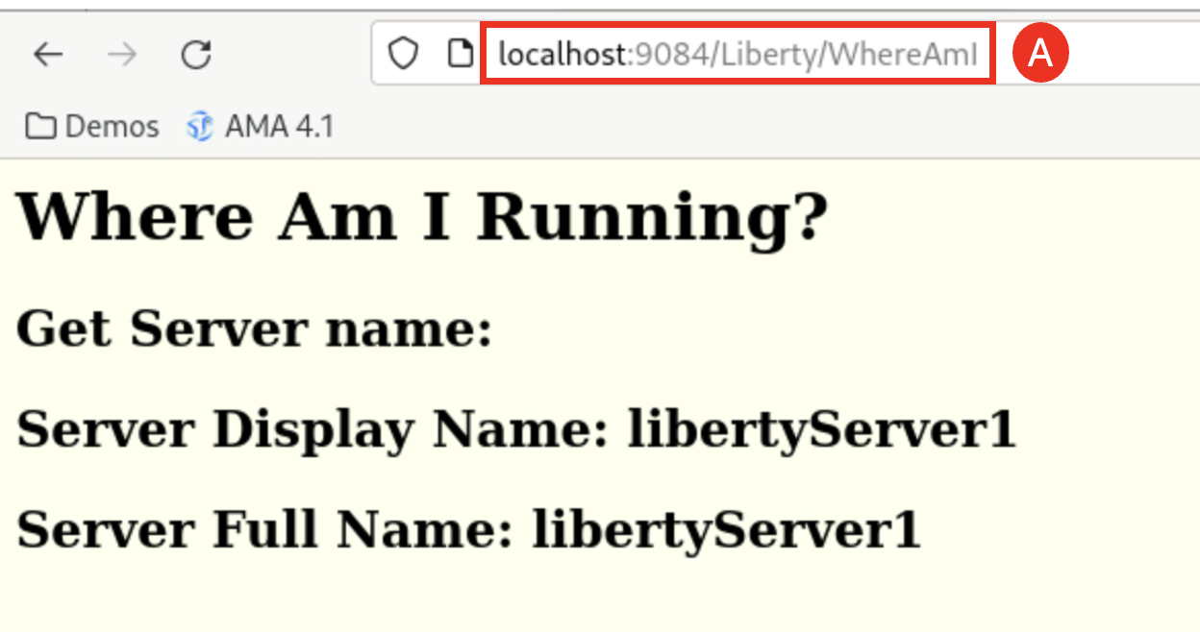

The **WhereAmI** application Home page is displayed.

* 1. Repeat the same steps **a** through **d** but select **libertyServer2** and its HTTP port (the port is **9085** in the screenshot below and your port number might be different), you can also access the application running on **libertyServer2**.

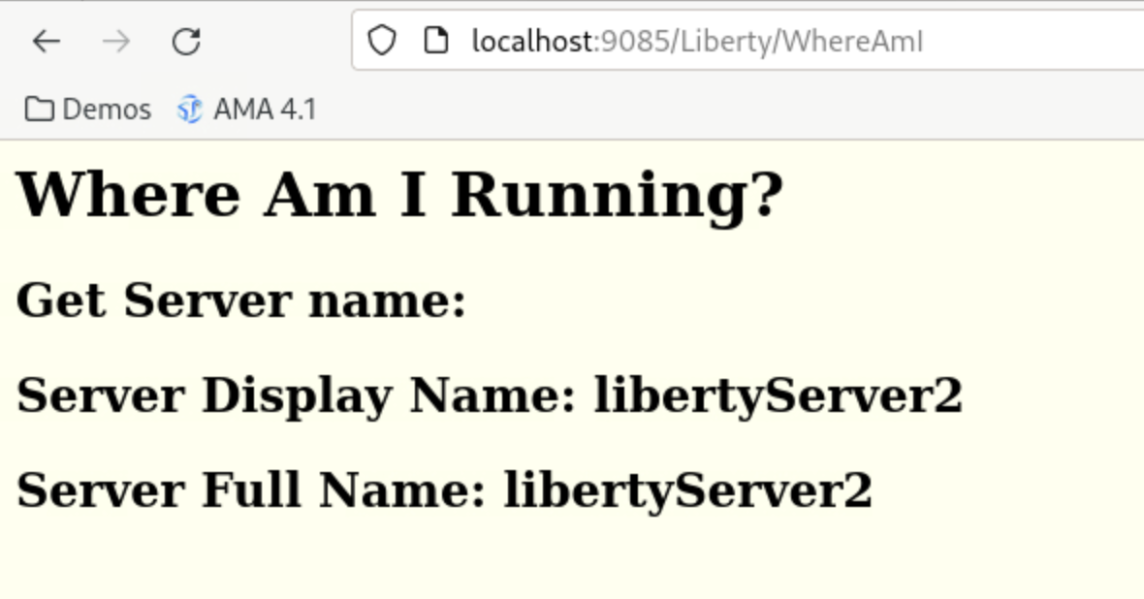

1. Review the Liberty server log file.
   1. To review the Liberty server log file, open the File Manager by clicking **Activities (A)** and clicking the **File Manager icon (B)**.

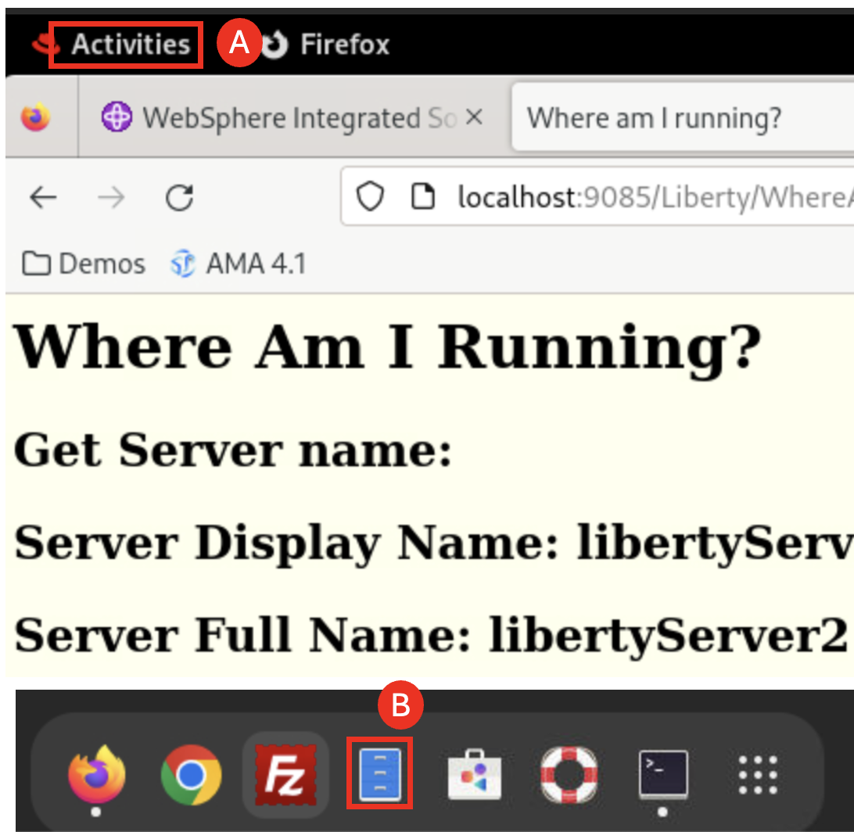

* 1. In the File Manager, navigate to **/home/techzone/IBM/WebSphere/AppServer/profiles/AppSrv01/managedLiberty/usr/servers/libertyServer1/logs** directory and select the **messages.log file (A)**.

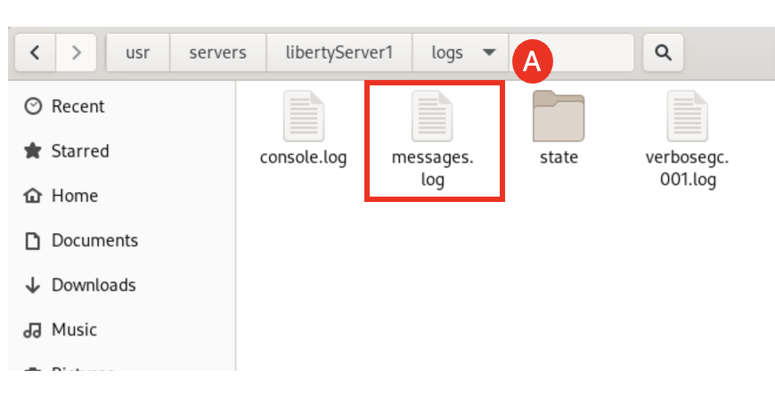

Now you see the **libertyServer1** log file and you can see the Liberty version and Java version it is used and the application URL.

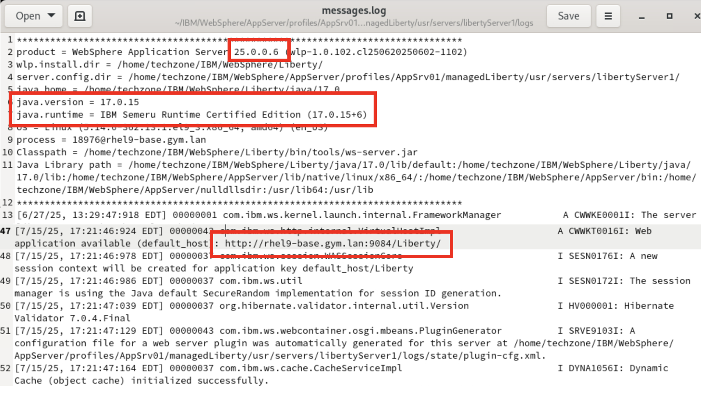

1. Generate and Propagate the Web Server plugin configuration to IBM HTTP Server.

We have run the application in the individual Liberty server, now let’s config and run the application through the IBM HTTP server, IHS.

1. From the terminal window, start the IBM HTTP Server with the command:

cd /home/techzone/IBM/HTTPServer/bin

./apachectl start

1. Back to WAS Admin Console page and navigate to **Servers (A)** > **Server Types (B)** > **Web Servers (C)**.

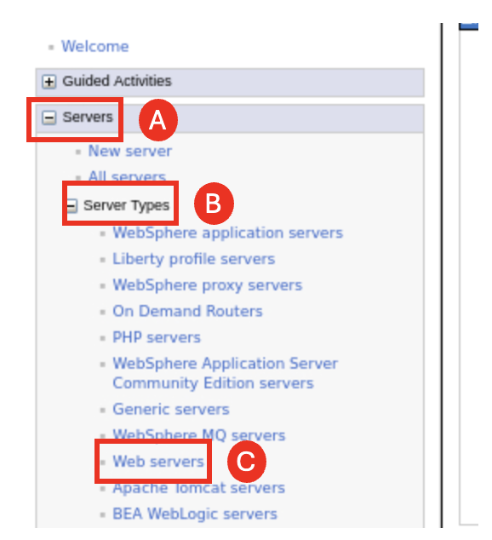

1. Check box next to **webserver1 (A),** click **Generate Plug-in (B)** to generate the web server plugin configuration file based on the current configuration of managed Liberty servers deployed in the **MLSCluster.**

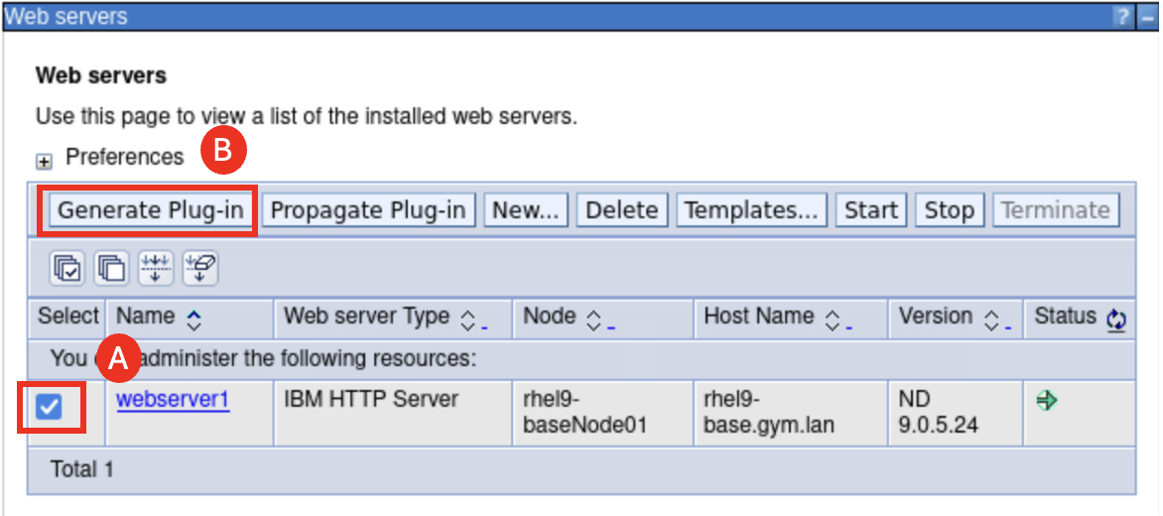

The **Generate Plug-in** action generates an updated version of the “**plugin-cfg.xml**” file that the IBM HTTP Server uses to determine which WAS/Liberty servers the incoming request route from the HTTP server.

1. Check box next to **webserver1 (A),** click **Propagate Plug-in (B).**

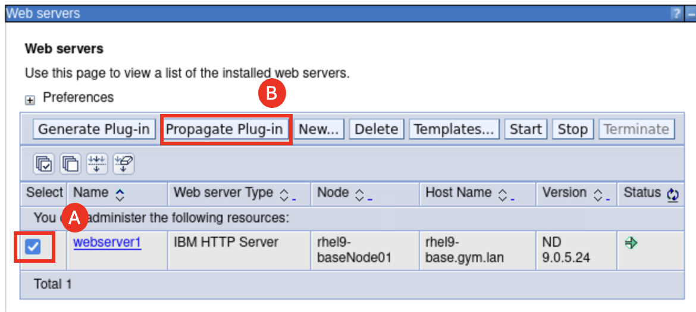

The **Propagate Plug-in** action moves the updated version of the “**plugin-cfg.xml**” file to the defined location that the webserver1 is expecting to find the file based on the IBM HTTP Server configuration.

The HTTP Server loads this configuration file into memory for routing and load distribution of incoming requests.

1. View the IBM HTTP Server **plugin-cfg.xml** file to see how it is configured to route requests to the managed Liberty servers.
   1. Form the terminal window, run the command:

gedit /home/techzone/IBM/WebSphere/Plugins/config/webserver1/plugin-cfg.xml &

As you can see that the **ServerCluster** section defines the WebSphere cluster and managed Liberty servers and their ports that are configured for the HTTP server to route and distribute WebSphere requests.

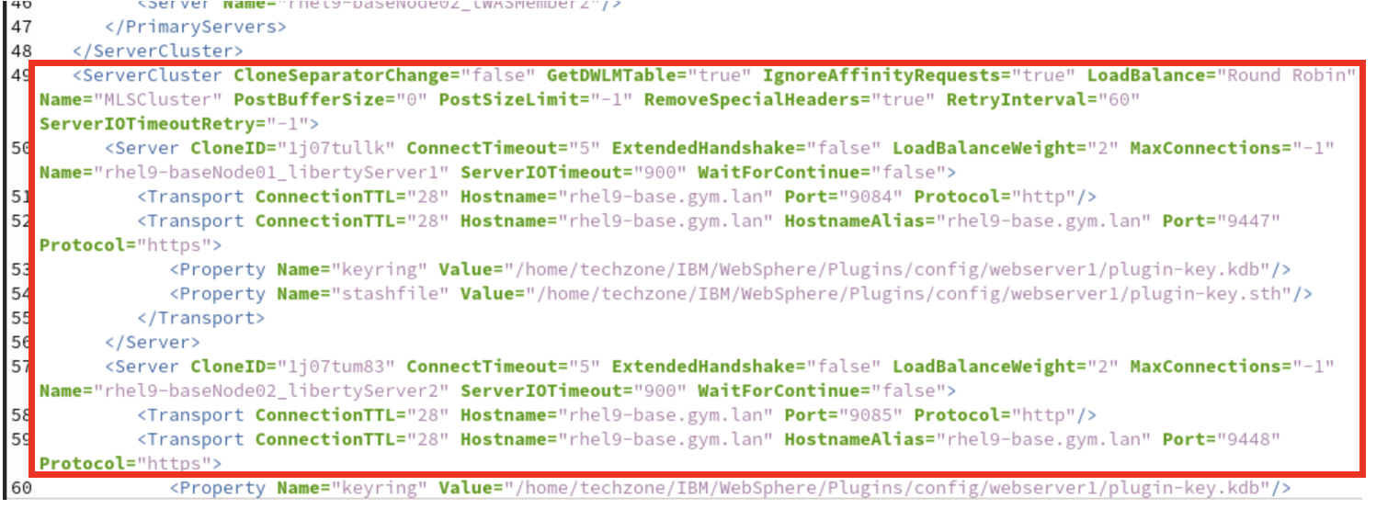

The **UriGroup** maps the URL requests for “/Liberty” to the MLSCluster of managed Liberty servers.

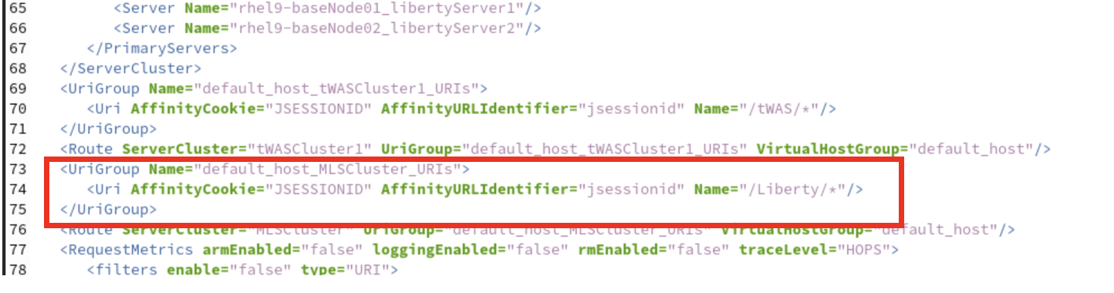

* 1. **Close** the **plugin-cfg.xml** file. DO NOT MAKE ANY UPDATES.

1. Access the IBM HTTP Server on port 8080
2. Open a new browser tab in **Firefox** browser in the lab environment and navigate to the HTTP server URL: **http://localhost:8080 (A)**.

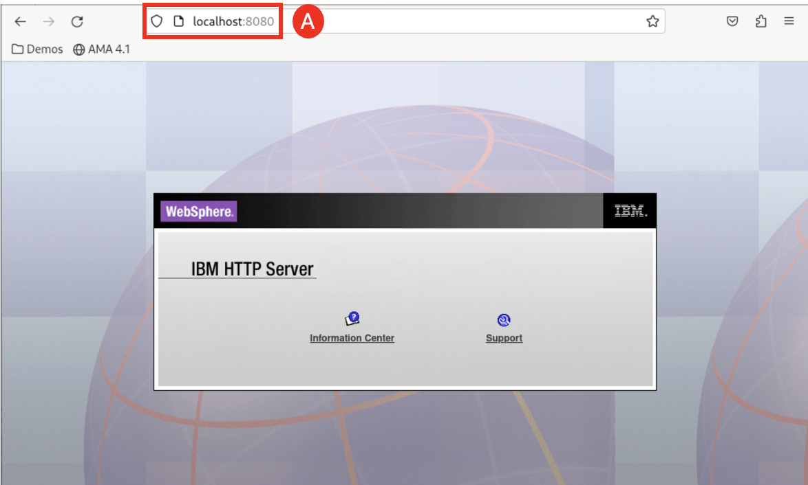

1. Run the **WhereAmI** application through the IBM HTTP Server that is running on port 8080
2. Open a new browser tab browser in the lab environment and navigate to the **WhereAmI** application using the context root **“/Liberty**”: **http://localhost:8080/Liberty/WhereAmI (A)**.

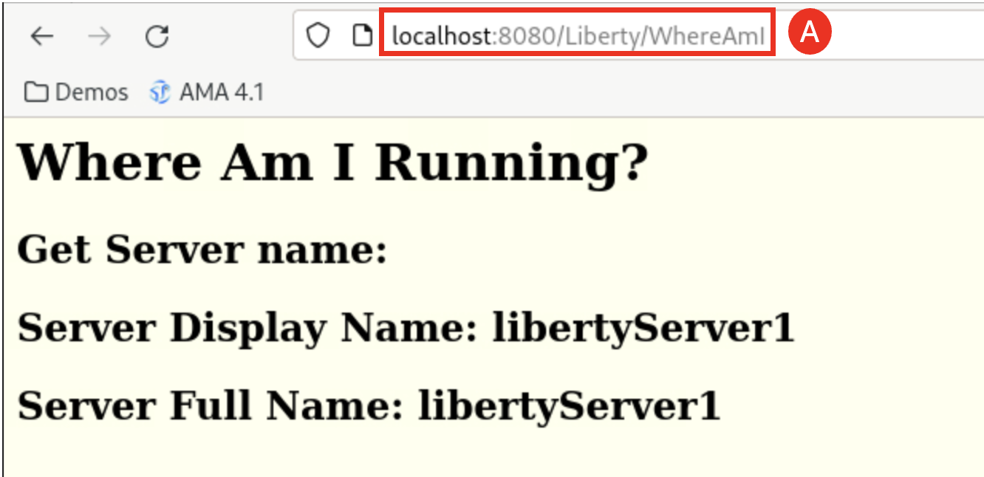

The application page is displayed.

1. Change the Liberty server port to see what is going to happy to the IHS configuration.
   1. From the WAS Console, navigate to **Servers** > **Server Types** > **WebSphere application servers** and select **libertyServer2 (A)**.

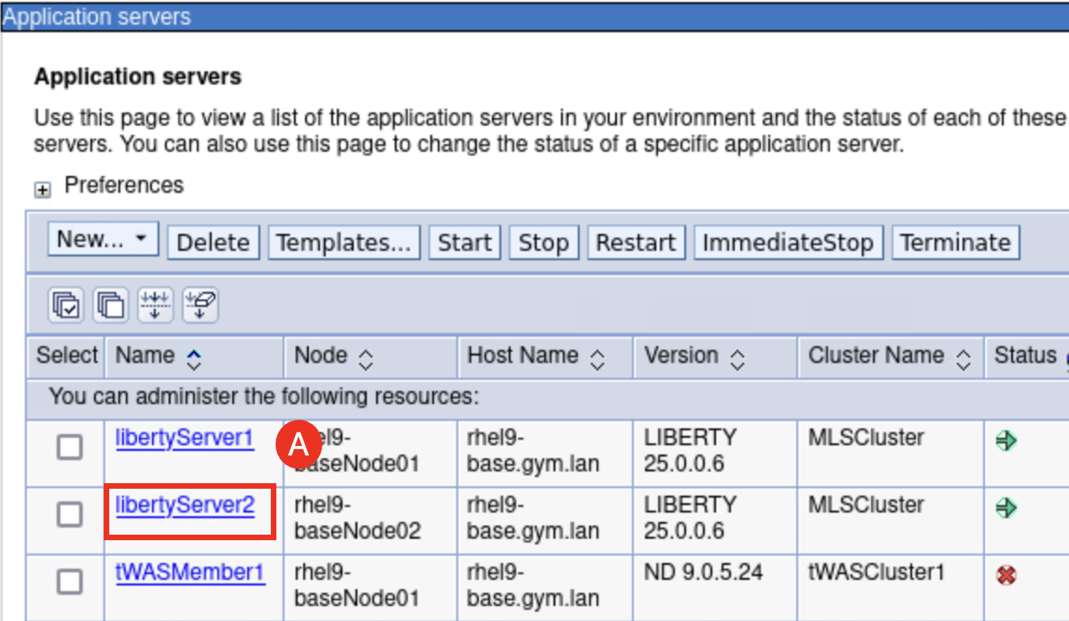

* 1. Click **Ports (A)**.

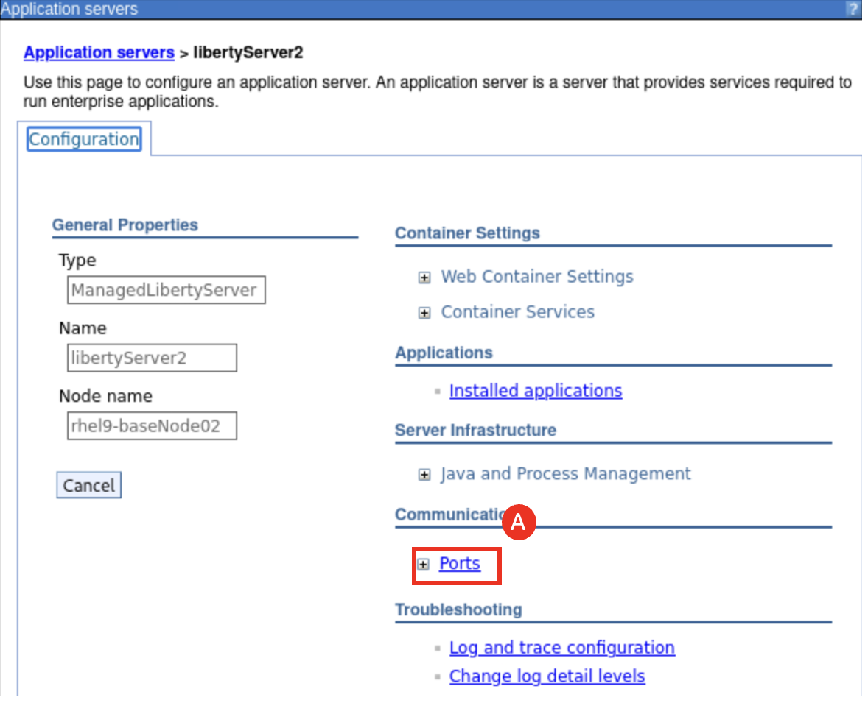

* 1. Click the **default port link (A)**.

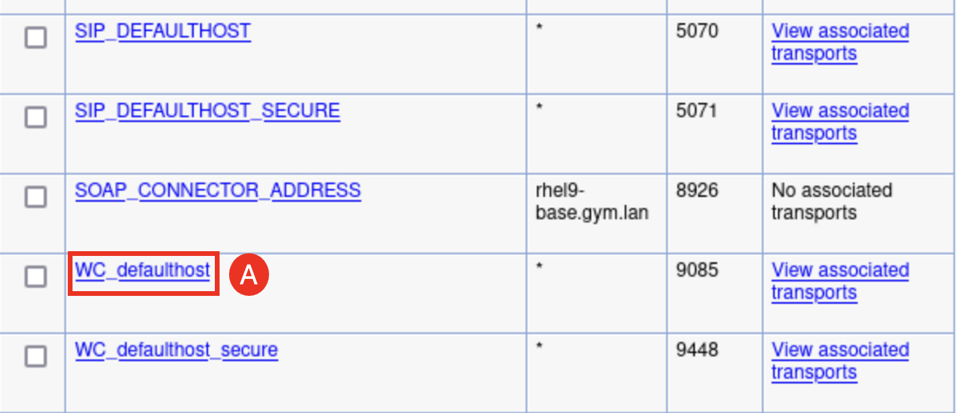

* 1. Change the default port value from to **9086 (A)** and click **Apply (B)**.

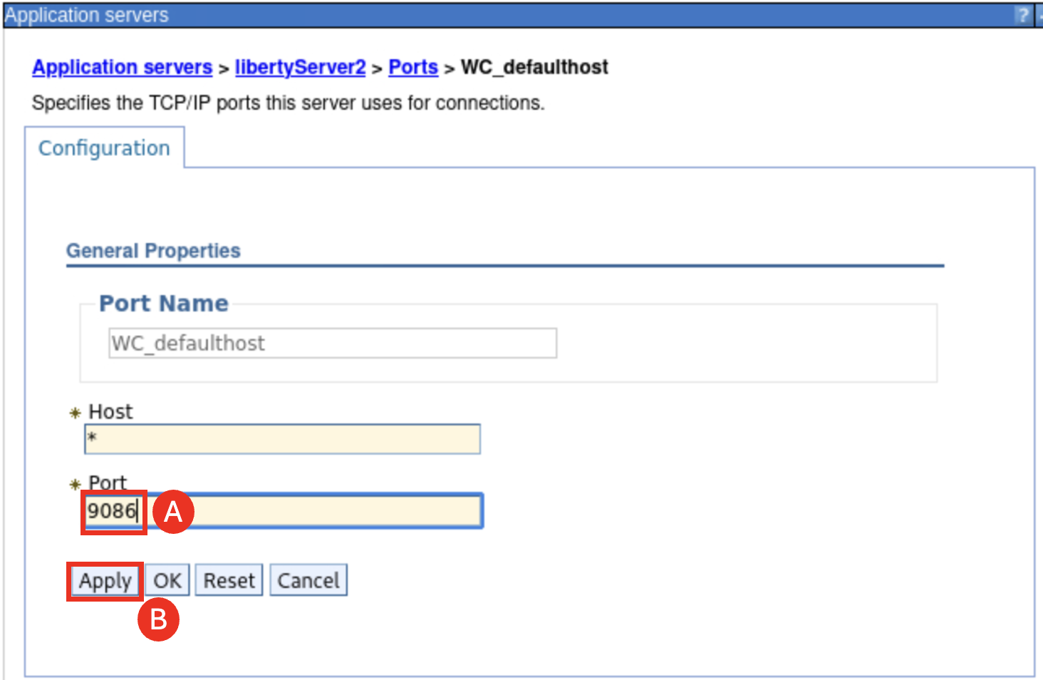

* 1. Click **Save (A)** to save the port number change.

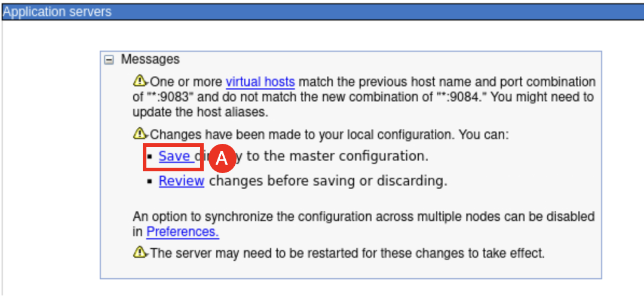

Notice that the warning message about host aliases update.

* 1. Click **OK (A)** to confirm the change.

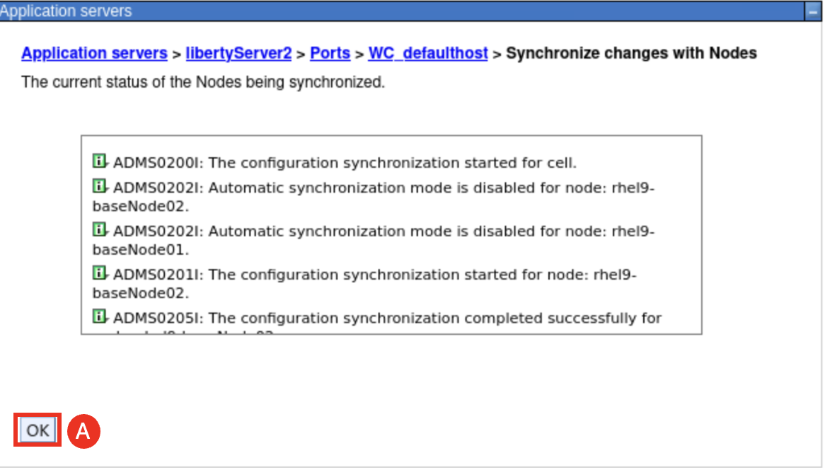

The port now is changed to 9086.

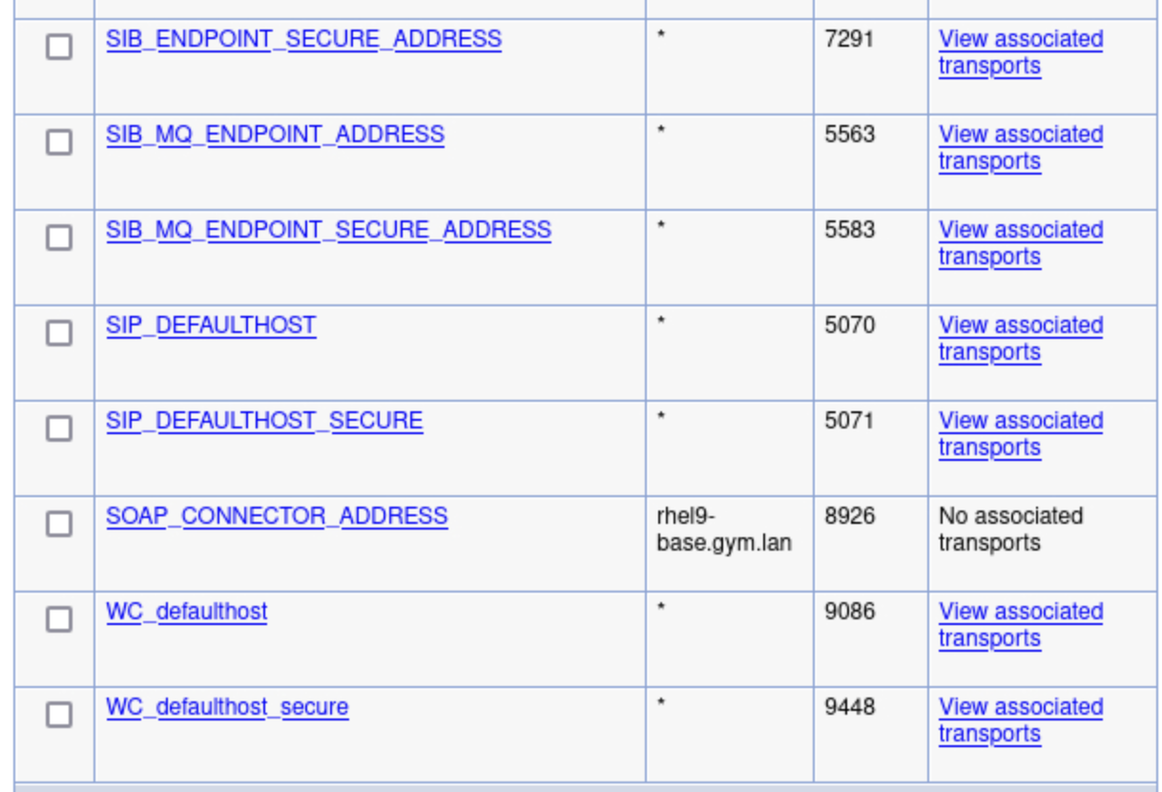

* 1. To check if the port 9084 is in the host aliases or not, navigate to **Environment (A)** > **Virtual Hosts (B)**.

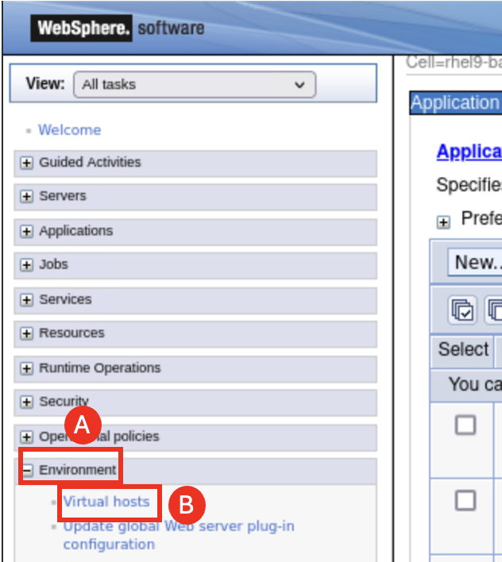

* 1. Click **default_host link (A)**.

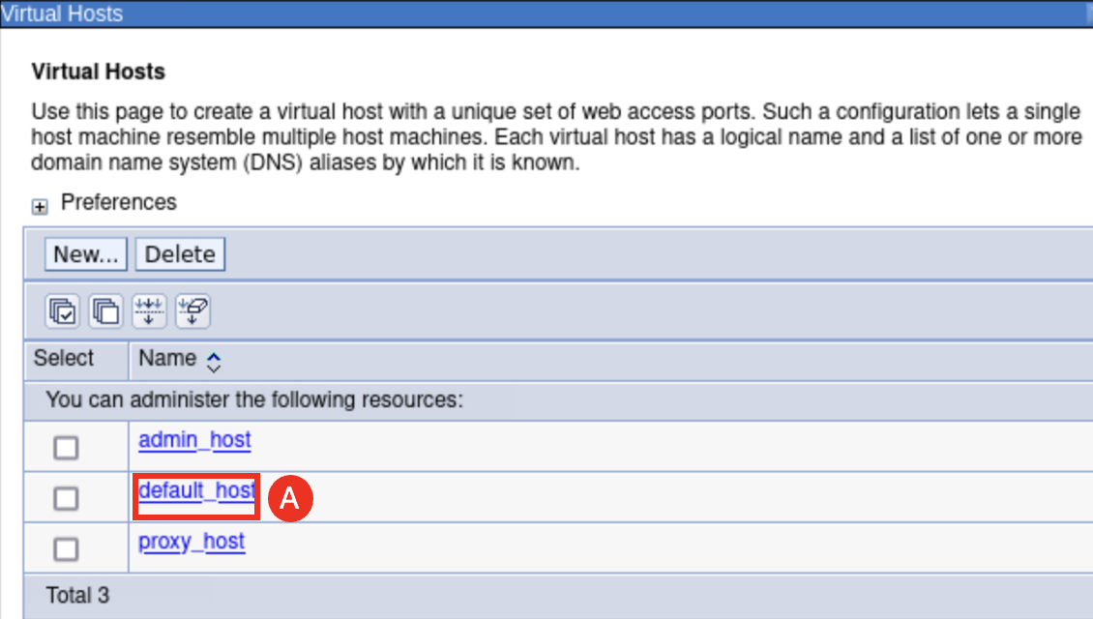

* 1. Click **Host Aliases (A)**.

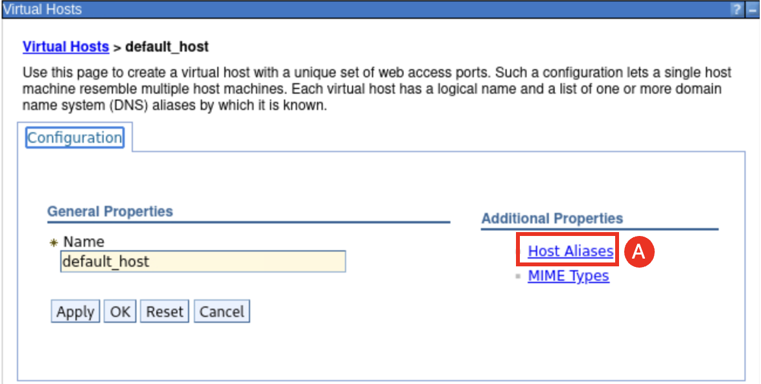

The Host Aliases is listed and as you can see that the port 9086 is not in this list and needs to be added.

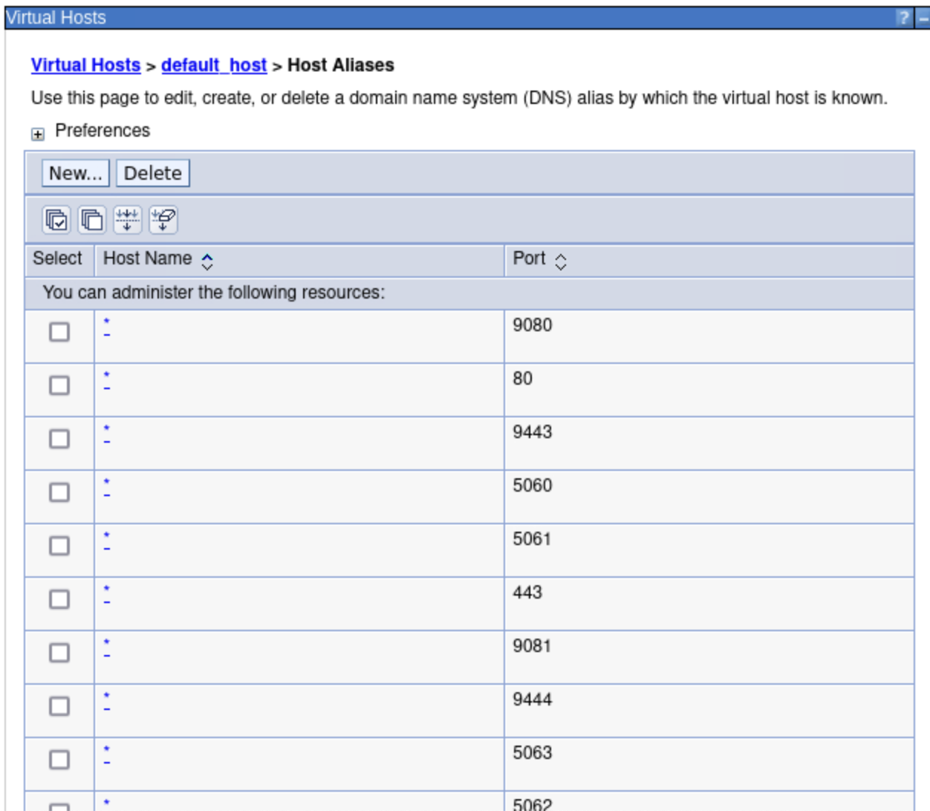

* 1. To add the new port number, click **New… (A)**.

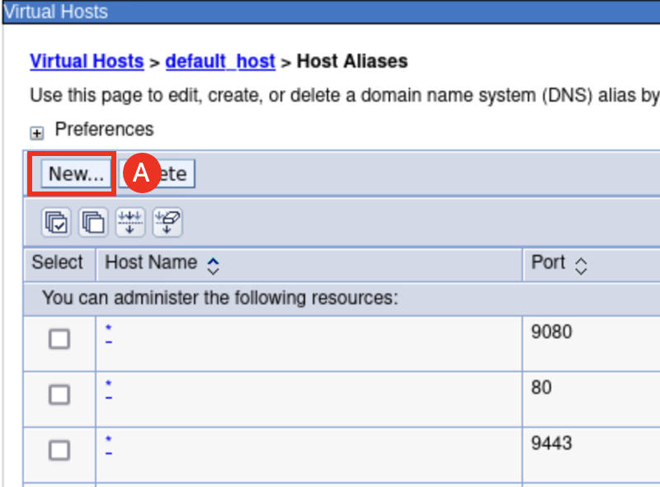

* 1. Enter **9084 (A)** and click **Apply (B)**.

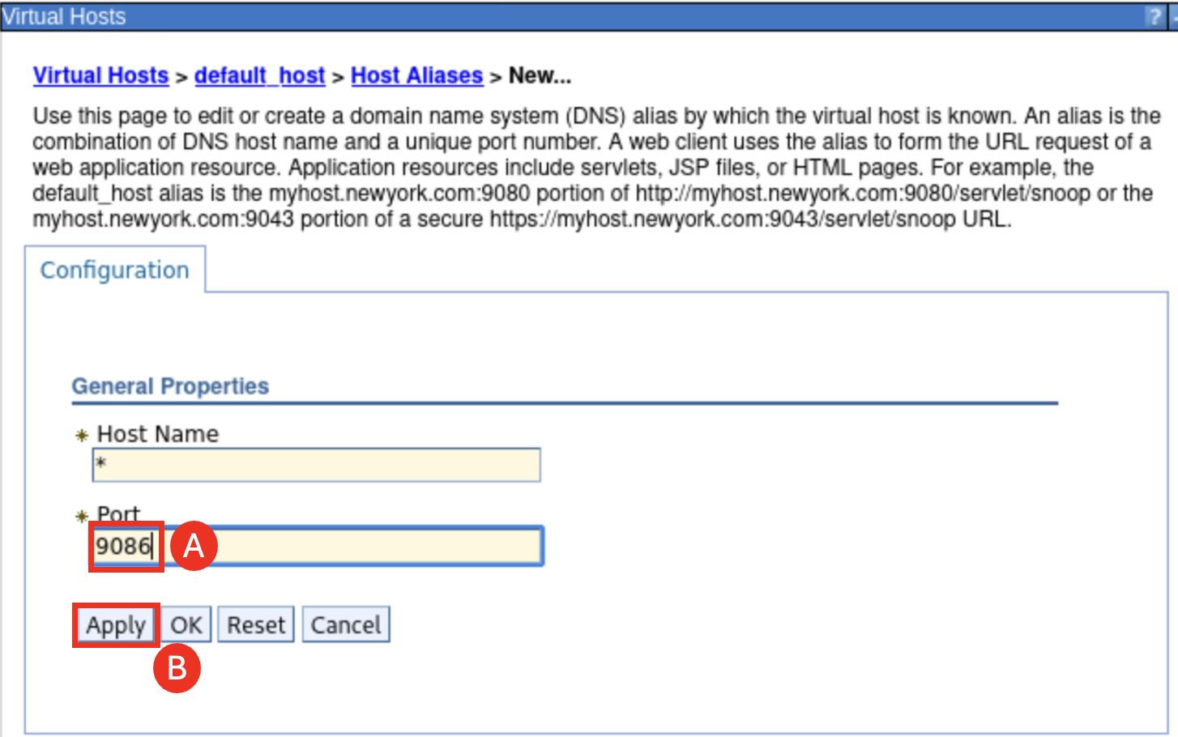

* 1. Click **Save** and click **OK**. Now the port number **9086** is added to the Host Aliases.

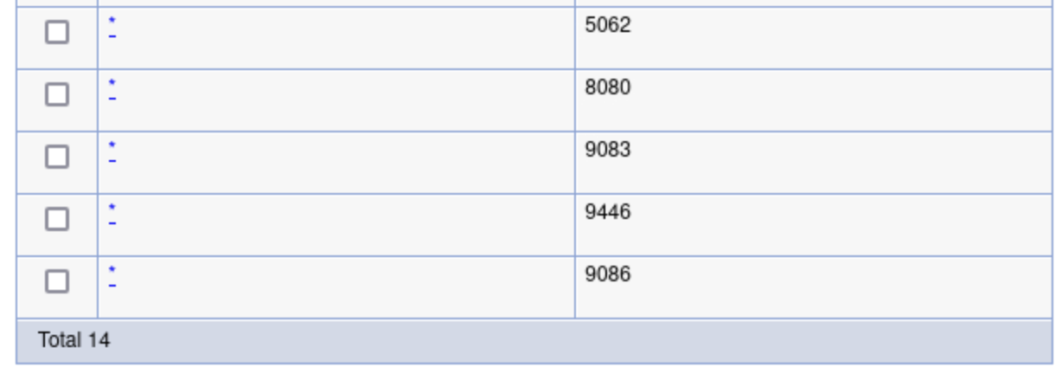

* 1. Next let’ check the IHS **plugin-cfg.xml** file to see if it is updated with the new port we just added. Form the terminal window, run the command:

gedit /home/techzone/IBM/WebSphere/Plugins/config/webserver1/plugin-cfg.xml &

As you can see that the xml file has be automatically updated with the port number **9086**.

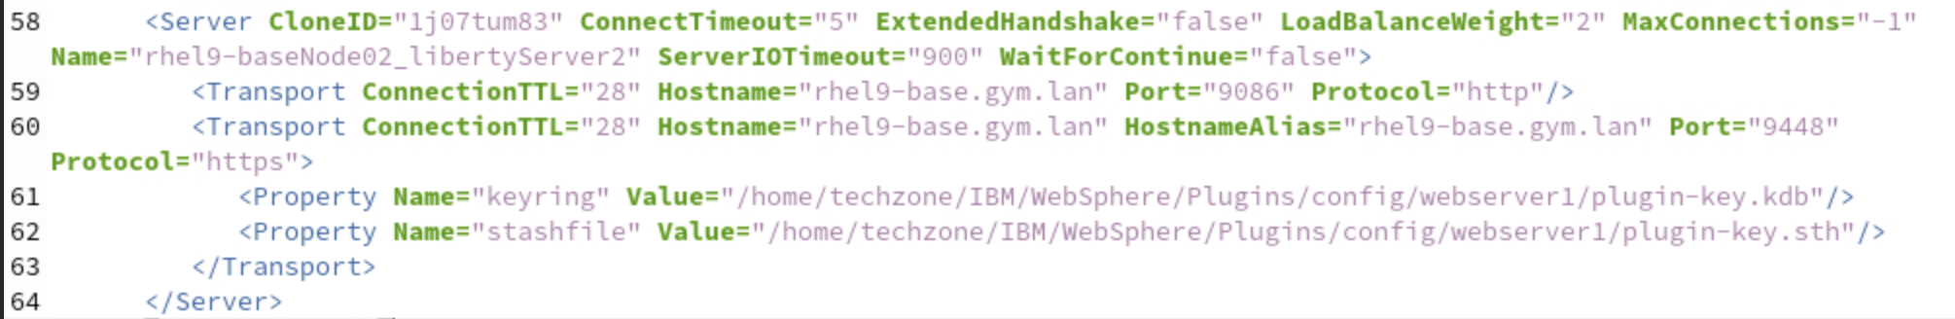

1. Test the high availability of the IHS plugin configuration.
   1. From the WAS Console, navigate to **Servers** > **Server Types** > **WebSphere application servers** and check the box next to **libertyServer1 (A)** and click **Stop (B)** to stop **libertyServer1**.

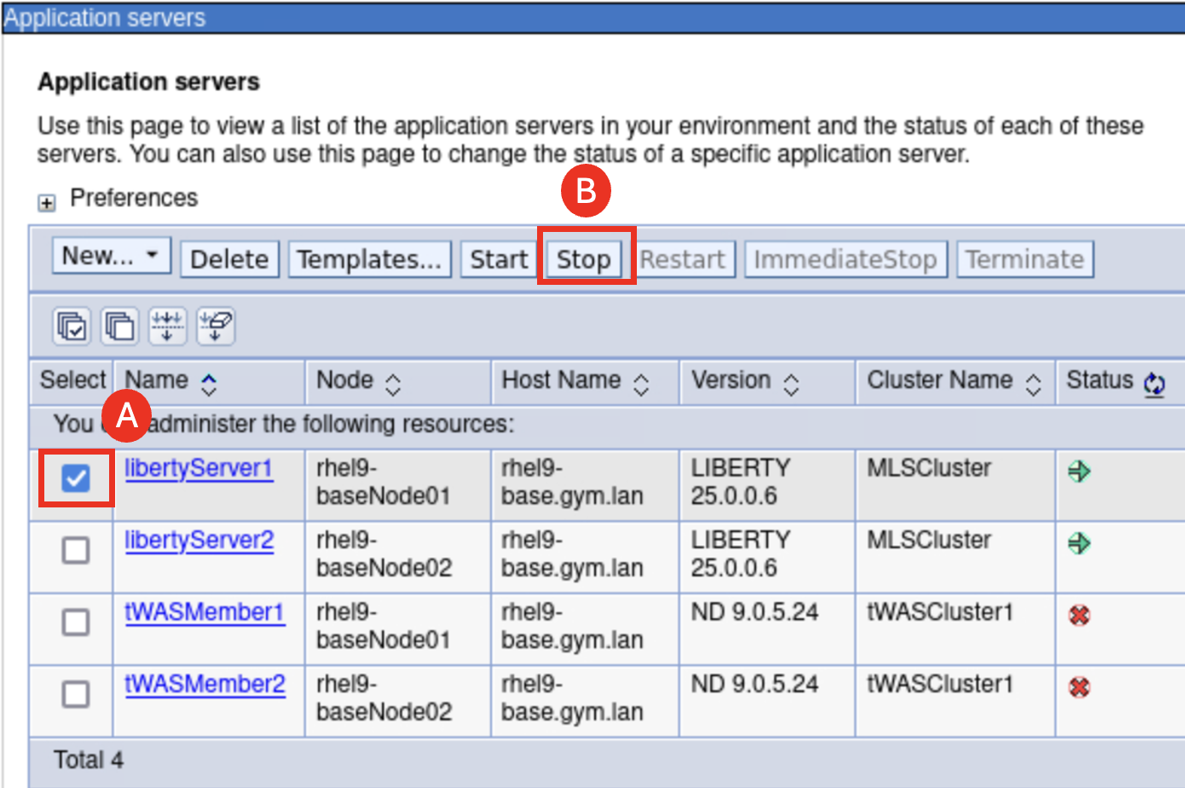

* 1. Click **OK (A)**.

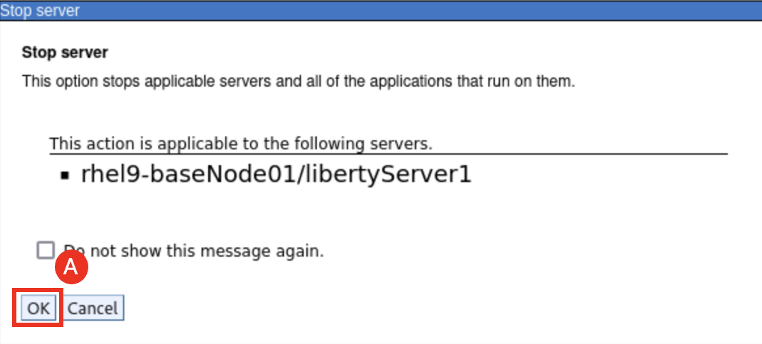

The **libertyServer1** is now stopped.

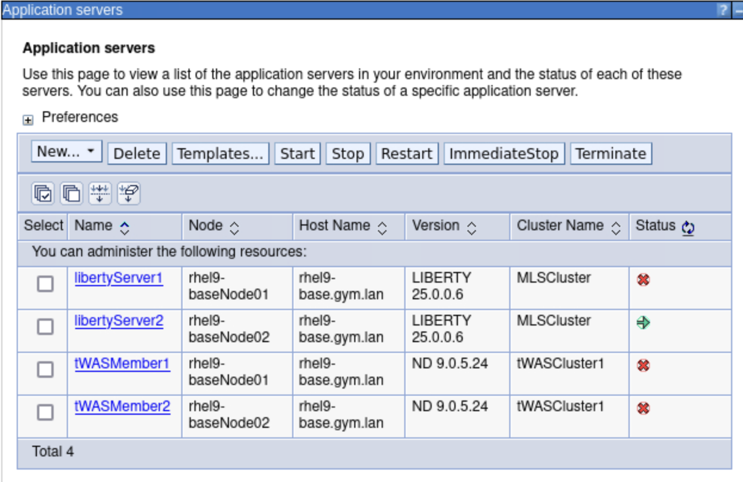

* 1. Go back to the browser window and access **WhereAmI** application using the IHS URL: **http://localhost:8080/Liberty/WhereAmI**, you can see that the application is still running on **libertyServer2** with the now port **9086**.

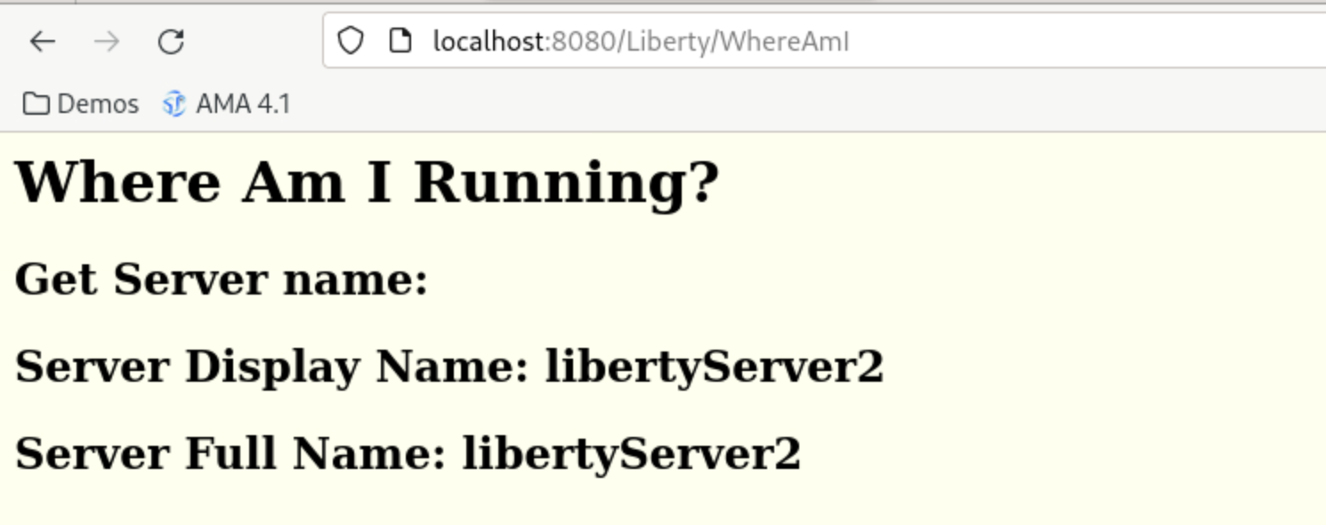

**Summary**

In this lab, you learned how Java 17 applications can be deployed and managed via managed Liberty severs in an existing WebSphere Application Server – ND cell using IBM Modernized Runtime Extension for Java (MoRE).

In this scenario, you explored:

* Using the very familiar WebSphere Administrative console for administering Liberty servers
* Create a WebSphere cluster of managed Liberty servers
* Install Java 17 applications to the WebSphere cluster
* View wsadmin commands generated by the command assistant in the admin console
* View the managed Liberty server logs
* Generate and propagate the WebSphere plugin configuration for IBM HTTP Server
* Run the mod resorts application through the HTTP server routing requests to the cluster of managed Liberty servers

